

Adapt IT Consulting and Training

**ITS INTEGRATOR 4.1 – TRAINING MANUAL**

**STUDENT SYSTEM**

**Residence iEnabler**

Copyright

©All rights reserved

No part of this document may be reproduced or transmitted in any form or by any means, without express written permission from Adapt IT or an authorised representative of Adapt IT. This includes, but not limited to, electronic, electrostatic, magnetic tape or mechanical copying and recording, or use of any information storage and retrieval system.

Disclaimer

Adapt IT makes no representations or warranties with respect to the contents hereof. Although due care and precaution has been taken in the preparation of this manual, Adapt IT assumes no responsibility for errors and omissions or any damages resulting from the use of the information contained in this publication.

**Contents**

**Course Overview** 1

**Course duration** 1

**Pre-requisite knowledge and skills** 1

**Course content** 1

**Learning outcomes** 1

1.1 Module Structure 2

**System Access** 3

**Logging on to Integrator** 3

**Landing Page** 4

**Navigation** 4

**Exiting a form** 4

**1** **System Overview** 5

1.1 System Requirements 6

1.2 System Overview 6

1.3 System Dependencies 6

1.4 System Setups in the Back Office 7

1.4.1 Maintain System Cycles {SMNT-2} 7

1.4.2 Validation Report/Choice {SMNT-1} 7

1.4.3 Business Functions {STWEBM-1} 9

1.4.4 Business Functions Processes {STWEBM-1} Tab 2: 10

1.4.5 Process Event Code Structure {STWEBM-7} 12

1.4.6 System Operational Definitions (SOD) {SMNT-12} 13

1.4.7 Residence Quotas {SRESIDE-3} 16

1.4.8 Bulk Residence Admission {SRESIDE-16} 16

1.4.9 Excluded students 17

**1.4.10** **Search Criteria** 17

**1.4.11** **Quotas** 19

**1.4.12** **Buttons** 19

**1.4.13** **Detail Fields** 20

1.4.14 Residence Registration Rules {SRESIDE-2} 26

1.4.15 Processing Rules 28

**2** **Residence Application Function** 29

2.1 View/Update Personal Information 30

2.2 Residence Rules and Regulations 30

2.3 Submit Residence Application 31

2.4 Cancel Residence Application 33

**3** **Residence Registration Function** 34

3.1 Residence Registration Rules and Regulations 35

3.2 Submit Residence Registration 36

3.3 Residence Proof of Registration 38

**4** **Student Enquiry Function** 40

4.1 Residence Admission Status 41

**5** **Operational Issues** 42

**6** **Residence iEnabler Implementation – Responsible User** 47

**Acronyms, Glossary & Terminology** 49

**Acronyms** 49

**Glossary** 50

**Terminology** 51

**Help us enhance the course** 53

**Need help?** 54

**Course Overview**

Welcome to the Residence iEnabler course for Integrator 4.1. This course is designed to equip you with the skills and knowledge you need to be able to use Residence Application and Registration iEnabler.

**Course duration**

3 days

**Pre-requisite knowledge and skills**

Before you can register for this course, you must have successfully completed the ITS Integrator Interface Training course or at least be familiar with the Integrator system.

**Course content**

The course is divided into modules and covers the following topics:

|  |  |
| --- | --- |
| **Subsystem** | **Modules** |
| Residence iEnabler Subsystem | * System Overview * System Requirements * Residence Application Function * Residence Registration Function * Student Enquiry Function * Operational Issues |

**Learning outcomes**

On completion of this course, the trainee should be able to:

* Know which setups has to be in place in order to make the Residence Registration iEnabler run smoothly.
* Understand the business function process.
* Know how to capture new records and update existing records on the Residence iEnabler.
* Know about all the options that exist on the Residence iEnabler.

## Module Structure

Each module contains the following parts:

**Specific outcomes**

The specific outcomes are very important because they state what is expected of you.

**Introduction**

Each module starts with a statement of the content and learning outcomes for that module in order to introduce you to the subject matter of the module. Suggested time allocation is also indicated. Bear in mind that the time allocation is only a guide and some people will take longer than others to complete the same task. The timeframe can also be longer if you choose to look up content from other resources.

**Content**

Module content consists of information moving from system pre-requisites to operational and menu management issues. The content is subdivided into topics, tasks, procedures and other information arranged in a logical sequence and broken down into small, connected and understandable units. This content can be supplemented by support materials such as PowerPoint presentations, worksheets, hand-outs, etc.

**Acronyms, Glossary and Terminology**

As far as possible, the workbook uses clear and non-technical language. However, it is inevitable that you will be introduced to new terminology or be faced with the use of acronyms to describe or explain the contents of this manual. All terminology and/or acronyms used will be explained in the content, but you will also find separate structured tables at the end of this manual.

**System Access**

**Logging on to Integrator**

To access Integrator you need the use of Internet Explorer. Using your browser, use the URL relevant to your institution or link from the institutions’ local Intranet. You will be prompted for your user name and password. Username and passwords are set up in User Access Definitions {USERS-5} and maintained by the institution. A user can have multiple logins with the same user ID. It is dependent on institution rules and policies. Additionally, unsuccessful logging attempts might be limited to a specific number depending on the institution’s policy.

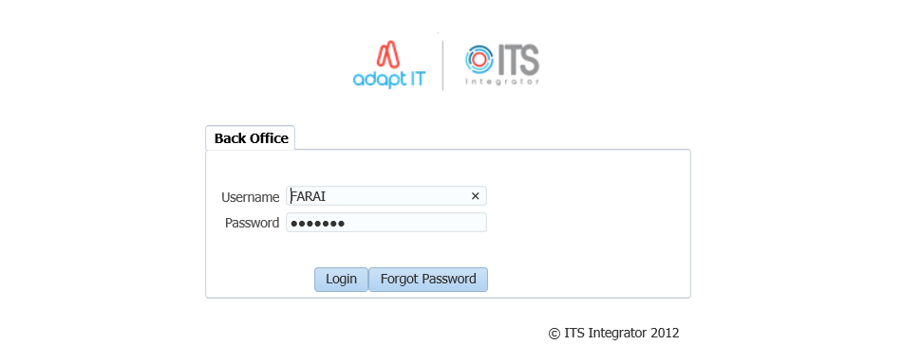

1. Type in your username and password
2. Click on the Login button

**Landing Page**

After logging into the Integrator Back Office System, the Integrator Entry Screen will display. The Integrator Entry Screen is the gateway to the full Integrator Back Office System and consists of four sections: Header, Main Menu Bar, Work Area, Welcome and Footer.

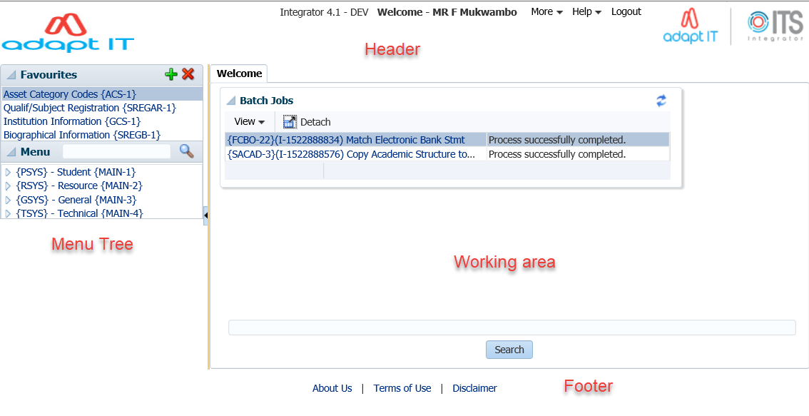

**Navigation**

Integrator 4.1 requires that you use the mouse to move from one field to another. In previous versions, the user could navigate between fields using the Tab and Enter keys. However, the new ADF technology operates in a browser and shortcut keys do not always give the intended output.

**Exiting a form**

Use the Green door  (old forms) or the black cross   (new ADF forms) to exit forms programs in Integrator 4.1.

The Abort Option button is only for emergencies in the event of a menu option hanging.

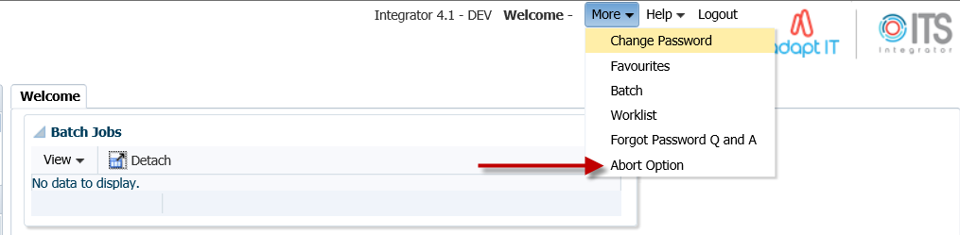

**MODULE**

**1**

# **System Overview**



Specific outcomes

On completion of this module, you will be able to:

* Maintain System Cycles
* Validate Report/Choice
* Maintain Business Functions
* Setup Business Function Processes
* Process Events Code Structure
* Update the Alpha/Date or Numeric fields

## System Requirements

* Internet Service Provider
* An Oracle Application Server
* A web address

## System Overview

The Residence iEnabler System has been developed to allow prospective and current students to apply and register for hostel accommodation via either the Internet or the Intranet of the institution. Current functionalities include:

* Residence Application
  + View/Update Personal Information
  + Residence Rules and Regulations
  + Submit Residence Application
  + Cancel Residence Application
* Residence Registration
  + Residence Registration Rules and Regulations
  + Submit Residence Registration
  + Residence Proof of Registration
  + Proof of Residence
* Student Enquiry
* Residence Admission Status

## System Dependencies

The residence application/registration process is directly dependent on the following setups in the Back Office:

* Business processes and steps as defined in {STWEBM-1} {STWEBM-2} and {USERS-1}
* Process Event Code structure in {STWEBM-7}
* Several validations that is turned on or off in {SMNT-1} Tab: Validation Control
* System Operational Definitions (SOD’s) in {SMNT-12}
* Definition of Residence Registration Rules in {SRESIDE-2}
* Ensure “W1” batch queue is opened in {BATCH-3}, block 2 – Active Queue Processes
* System Cycles {SMNT-2}
* Census Dates {GOPS-1}
* External Conversion Codes for External Body “INE”, External Code “077” (Rules and Regulations)–{GOPS-21}
* Residence Fee structure in {FSAM-1} and {FSAC-21}
* Accurate and updated information of Asset Register {AOPS-1}
* Document Group for Proof of Registration {GMNT-14}
* Report output for Proof of Registration {USERS-11}
* Bulk residence admission {SRESIDE-16}

The Residence Registration process can only be used by students:

* with an admitted residence application status in {SRESIDE-11}
* that is academically registered for a non-exam only block code on qualification level
* that complies with the rules as set up in {SRESIDE-2} as per the institutions rules and regulations document

System setups dependencies on {SRESIDE-2}:

* Residence buildings must be defined with aggregate code = 9 in {SPCS-4}
* Residence buildings, floors and rooms must be defined in {SPOPS-1} with:
* category 1900 to 1999
* the correct number of stations
* Campus code must be linked to offering type code in {GCS-5}
* Qualification codes must be correctly linked to Approved Qualification codes and Approved Qualification codes must be correctly linked to Qualification Types. Qualification and Approved Qualification codes are defined {SACAD-13} and Qualification Types in {SCODE3-1}

## System Setups in the Back Office

### Maintain System Cycles {SMNT-2}

Control cycles allow the user to limit the use of specific functions within the system to certain time windows during the year, and form an important part of the security of the system.

Even during the time of interval between the specified dates the user will be limited to creating records in respect of the specified years and academic blocks only.

**The following System Cycle types are applicable to the Residence iEnabler System:**

* P – Residence Application
* 1 – iEnabler Residence Registration

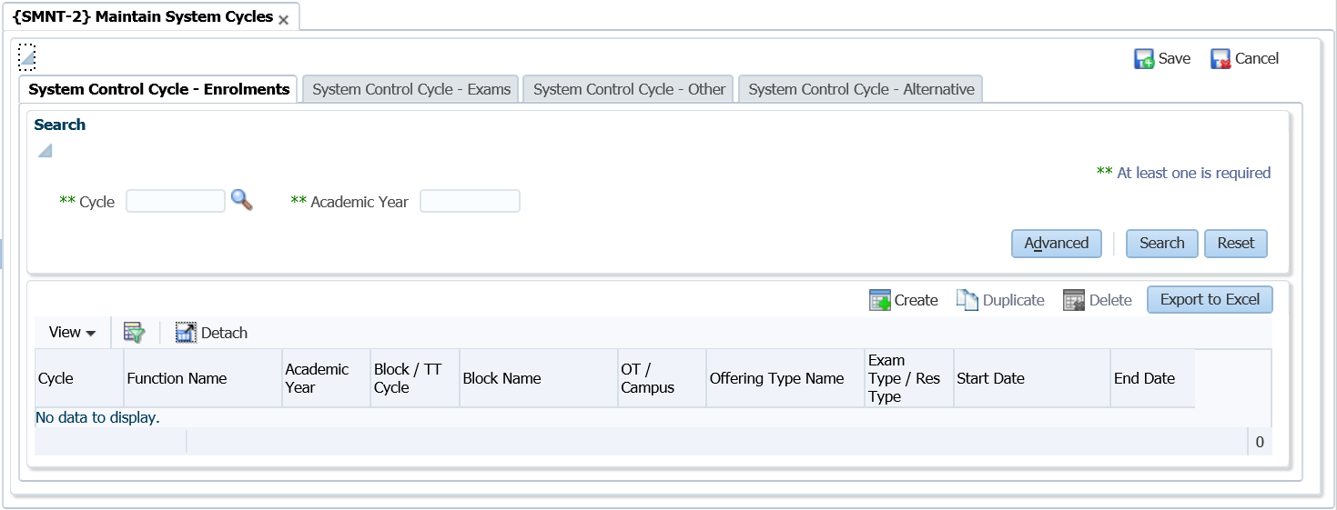

### Validation Report/Choice {SMNT-1}

This option handles two aspects: The control of a number of validations in the system and the control of the printouts that can be produced automatically during registration.

**Note:** Only tab 1 is applicable to the Residence iEnabler

**Validation Control {SMNT-1} Tab 1:**

The available functions are programmed into the system; the user cannot add or delete records but merely activate or de-activate them. The subsystem displayed on the screen is merely there to assist the user in finding the validations applicable to specific subsystems. Any changes to the on/off switches of the validations are written to a log file. The log file can be viewed by using option {SMNTL-5}.

The following validations apply to the Residence iEnabler:

* AH – Residence Application on Academic Application
  + The system will not allow the Residence Application for any students unless they were entered through option {[SNAPPA-1](http://hawkapp.its.co.za:7772/itshelp/help/topics/itshelp/documents/snappa-1.html)}, or admitted to the institution through option {[SNAPPA-3](http://hawkapp.its.co.za:7772/itshelp/help/topics/itshelp/documents/snappa-3.html)}

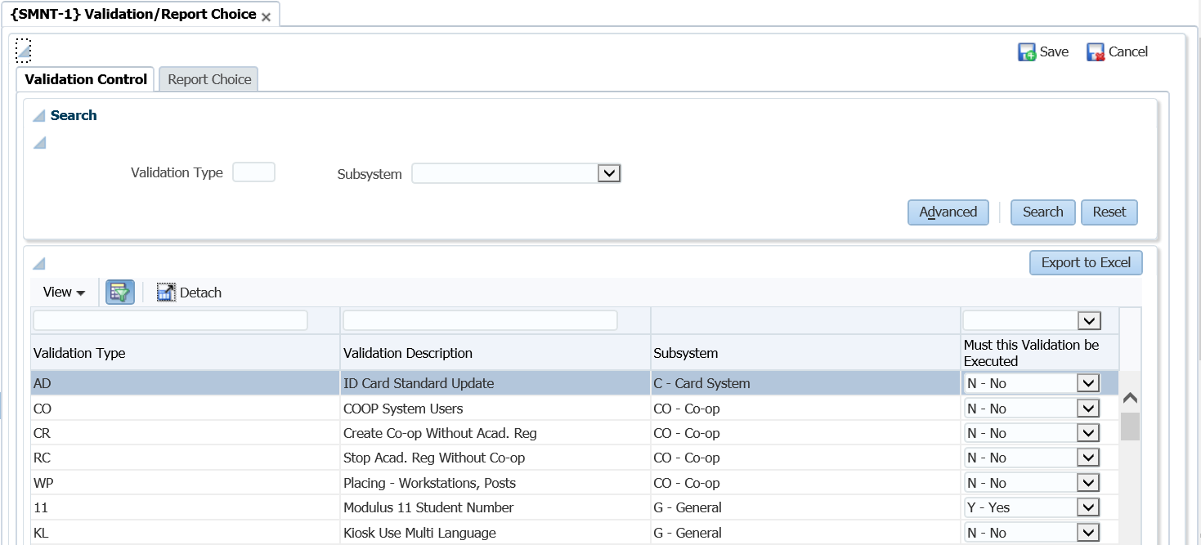

* AR – Academic Registration on Residence Registration
  + If the validation is set to ‘Yes’, no residence registration will be permitted unless the student has been registered academically

**Note:** If the rules in {SRESIDE-2} are activated and any of the rules that are active have requirements that are based on qualification registration information, the student will not be able to register in the residence.

* EE – DE Copy Residence Address to Study Address
  + If the validation is set to ‘Yes’, the study address of the student will be changed to the Residence address as defined in {[SPCS-4](http://hawkapp.its.co.za:7772/itshelp/help/topics/itshelp/documents/spcs-4.html)}
* HA – Residence Admission
  + If this validation is set to ‘Yes’, the system will not allow the registration of students in a residence unless they were admitted through option {[SNAPPA-4](http://hawkapp.its.co.za:7772/itshelp/help/topics/itshelp/documents/snappa-4.html)}
* RA – Copy Residence Address to Study Address
  + If this validation is set to ‘Yes’, the study address of the student will be changed to the Residence address, as defined in {[SPCS-4](http://hawkapp.its.co.za:7772/itshelp/help/topics/itshelp/documents/spcs-4.html)}

### Business Functions {STWEBM-1}

This program is used to maintain Business Functions used in the iEnabler Modules to set up a hierarchical structure of different Business Functions options to be accessed by the end user.

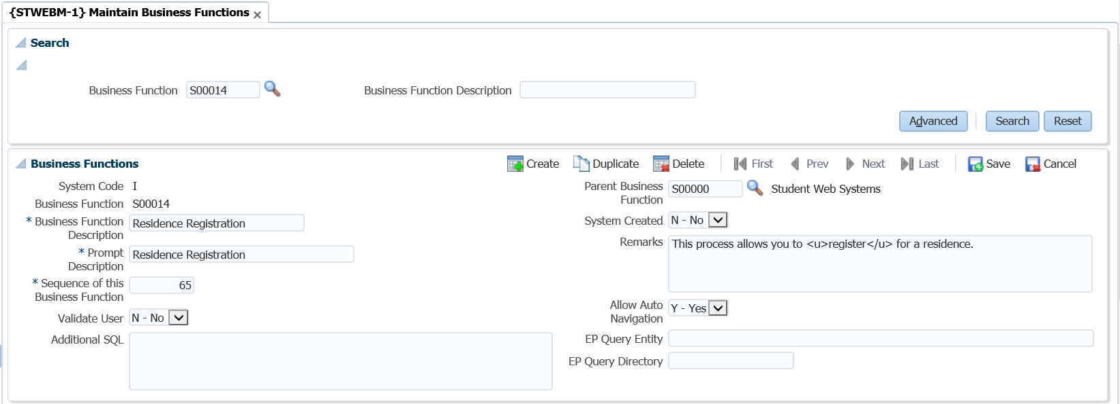

**Field Descriptions:**

**System Code:** The system code for this Business Function will be defaulted into this field. It is dependent on the menu option it is invoked: (I) Student (from STWEBM-1), (P) Personnel (from PWEBM-1).

**Code:** Business Function Code.

**Note:** For Business Functions, that is not "System Created", the Business Function Code should start with "N" or "O".

**Description:** A description for the Business Function.

**Prompt Description:** Enter a description at the prompt for this business function.

* For Business Functions used in the iEnablers, this is the description that will be displayed in the menu frame on the web system for this business function.
* For Business Functions used in Entry Points, this is the description in the left-top frame heading.

**Sequence of this business function:** For the iEnablers, the sequence in which the business function will be displayed within the parent business function supplied, if any. This field does not play a role in Entry Point- and Business Process Driver set-ups

**Validate ITS User:** For the iEnablers, a "Y"es will indicate that the end user should also be defined as a User in the User Access Definitions {USERS-5} before being able to use this Business Function. This field does not play a role in Entry Point- and Business Process Driver set-ups

**Additional SQL:** Not used

**Parent Business Function:** For the iEnablers, this field is used to indicate if the current business function is linked to a parent function, e.g. Application, Residence Application, Registration, etc., linked to S00000-Student Web Systems. This may be used to create the multi-level structure.

**System Created:** If ‘Y’ or ‘M’, the record is part of the standard ITS Software set-ups, may not be deleted and limited fields may be updated, otherwise the user has full control over the record.

**Remarks:** Enter any remarks regarding this Business Process

**Allow Auto Navigation:** For the iEnablers, will Auto Navigation within the Business Process for a particular Business Function be done. This field does not play a role in Entry Point- and Business Process Driver set-ups

**EP Query Entity:** For Entry Points, the name of the EP Query Entity without the extension. This field does not play a role in iEnabler- and Business Process Driver set-ups

**EP Query Directory:** For Entry Points, the directory for the EP Query Entity without the slash. This field does not play a role in iEnabler- and Business Process Driver set-ups

**Note:** Ensure that the following business processes are linked to the parent function S00000 (Student Web Systems):

* S00010 (Residence Application)
* S00014 (Residence Registration)

### Business Functions Processes {STWEBM-1} Tab 2:

This option is used to set up Business Function Processes and link them to the Business Functions as defined in {STWEBM-1}.

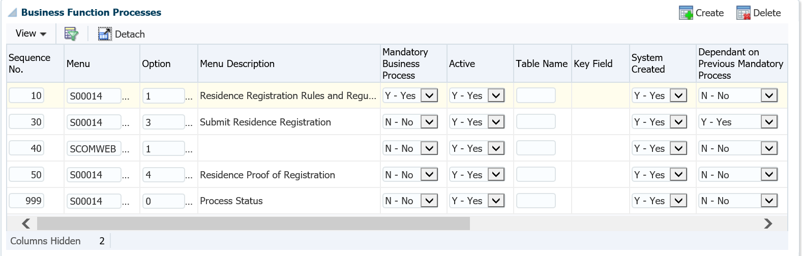

**Field Descriptions:**

**Query a Business Function:** Enter the Business Function to see the detail on the next block – Driver Detail.

**Sequence Nr:** Enter or change the display sequence of this business process in the business function.

**Note:** The number is usually incremented by 10 to leave space for later additions.

**Menu Code:** Enter value for Menu Code, as defined in {USERS-1b1}. This field, together with the Option field, will be used to retrieve the instruction to be executed by this Business Process.

**Option:** Enter value for the Menu Option, as defined in {USERS-1b2}.

**Option Description:** The description linked to the supplied menu code and option, as defined in {USERS-1b2}, will be displayed here.

**Mandatory Business Process:** Is completion of this business process mandatory for the completion of the business Function that it is coupled to?

**Active:** Is this Business Process active? For iEnablers, if this field is "N”, the process will not be available. Processes can be set to Active ="N" for a period and then re-activated when needed. An example of this is exam results that can be made inactive as a rule and only activated when the institution publishes their results.

**Note:** Only non-mandatory Business Processes may be made inactive. To set a mandatory process as inactive, you will first have to change the Business Process to Mandatory "N", before setting the Process Active "N".

**Table Name:** For Business Function Processes used in the Business Process Driver, the table together with the key field may be used to check whether this process has been completed, provided that the process results in the creation of a record in the database. This is only used when the process is defined as Mandatory ‘Y’.

**Key Field:** Enter a Value for key Column Number, as defined in {DMAIN-1b8 (columns)}.

**System Created:** If the system created field = "Y"(for users), then the following fields will not be able to be updated:

* Menu and Option
* Table name and key field.

**Dependant on Previous Mandatory Process:** Is this process dependant on another Mandatory Process?

* If a process is dependent on a previous Mandatory Process, the user will not be allowed to start the process before the dependant process is completed.
* If this field is set to (Y)es, the Dependency Sequence becomes mandatory.

**Dependency Sequence:** The sequence of the mandatory Business Process that must be completed before this option can be utilised.

**Additional SQL:** The Additional SQL Field also plays a role in restricting the count that is done to determine whether a mandatory business process was completed, if necessary. An example of adding Additional SQL would be adding Additional SQL to the "Application" Business Process as follows: Table Name would be "IER" (IERAAD), Key Field would be "1" (IAESTNO) and Additional SQL could be "IERCYR >= to_char(sysdate,'YYYY')". The resultant query will be built as: select count (ierstno) from ieraad where ierstno = v_unum and IERCYR >= to_char(sysdate,'YYYY'); The Additional SQL will make sure that the application records counted are only for the current and future years.

**Validation Rule:** Supply the rule that contains the validation for the step.

**Client Responsibility:**

* + As with all other iEnabler business processes it is the client’s responsibility that the options are linked to the business process in the correct sequence.
  + The user can link any other pages or programs to the business process in the desired sequence.
  + Indicate mandatory steps and dependencies.



**Note:** {STWEBM-2} Ensure that a minimum of the following steps are linked and is active for the business process:

| **Business Step** | **Program Name** | **Default Option** |
| --- | --- | --- |
| Residence Registration Rules and Regulations | w0004lll.w0004res_reg_rules | S00014-1 |
| Submit Residence Registration | ws18pkg.ws18_lst_frm | S00014-3 |
| Process Status | w99pkg.mi_bf_stats?x_busfct=S00014 | S00014-0 |

### Process Event Code Structure {STWEBM-7}

This option is used to define institutional specific parameters for a specific business process accessed via the iEnabler or an option executed via the back office, e.g. to indicate certificate codes to be inserted in the back-office system when the iEnabler user access a business process or to specify the number of unsuccessful login attempts.

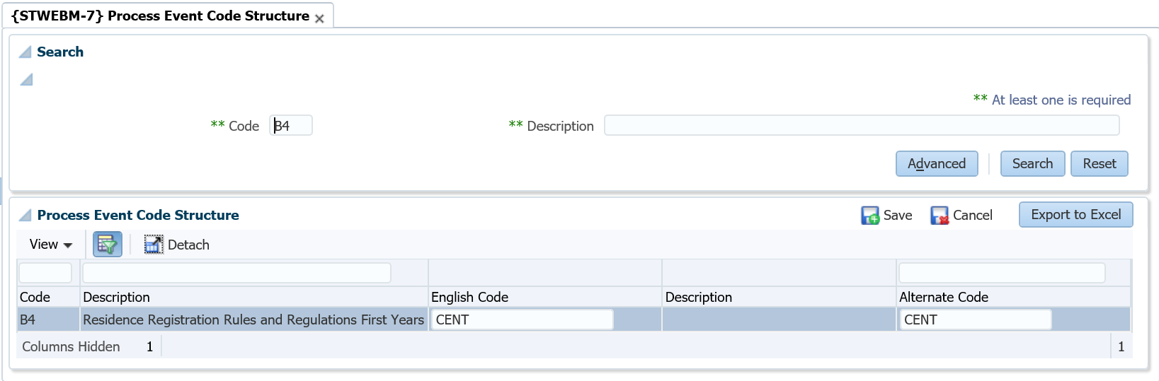

**Field Descriptions:**

**Code:** System created code(s) to be used in the iEnabler

**Code Description:** Description of the system created code

**English Code / Alternate Code:** The English Code and Alternate Code can be from different code structures. Letter codes can be entered in the English Code field or the Alternate Code field. The iEnabler user will be able to view the content of the letter on the iEnabler when the business process is accessed. If an institution prefers detail to be displayed according to the preferred language of the student the Alternate Code must be entered. These Process Event Codes are listed under the heading 'Letters' below.

* Some Process Event Codes are used to link certificate codes or indicators to students and those must be entered in the English Code field. These codes are listed under the heading 'Indicators' below.
* Other Process Event Codes control the display options and specific default values. These Process Event Codes are listed under 'Miscellaneous Events' below.

**Letters**: The letters displayed on the Web will depend on the student's preferred language. If the preferred language is not English but an Alternate Letter Code was not defined, the English letter will be displayed.

**The following codes must be linked to document codes, as defined in {GMNT-14}:**

* B1 – Residence Application Rules and Regulations
* B3 – Residence Application Contract Letter
* B4 – Residence Registration Rules and Regulations
  + Set both the English and Alternate codes to the appropriate document codes as defined in {GMNT-14}
  + When the student clicks on the ‘Rules and Regulations’ link, the system will display the document according to the student’s preferred language
* B6 – Residence Registration Contract Letter

**Indicators:** The following event codes are used to link certificate- or indicator codes from {SCODE-22} to students. These indicator codes must be entered in the English Code column.

* B2 – Residence Application Certificate Indicator
  + A certificate code as defined in {SCODE-22}, must be linked to Event Code ‘B2’. A record will be inserted in {SREGB-8} with an indicator seen set to ‘No’.
* B5 – Residence Registration Certificate Indicator
  + Set the English Code to the certificate indicator code for accepting the Rules and Regulations
  + When the student clicks on the ‘Rules and Regulations’ link and the certificate code is not linked to the student an ‘I Accept’ button will display on the page. When the student clicks the button, this certificate code will be linked to the student with the ‘Seen’ indicator set to ‘Yes’.

**Miscellaneous Events:** These codes control miscellaneous events like specific default values and display options.

* A8 – WR Status End Date
  + To indicate the end date to be linked to the student record on {STWEBM-9} when {STWEBM-3} is run to link statuses to students for iEnabler registrations
* ET – Expiry Time
  + To indicate the expired time for a session with no activity on the iEnabler.
* LA – Number of unsuccessful login attempts
  + Both English and Alternate codes must be entered, with the number of times the student can unsuccessfully try to login. Once this number has been exceeded, the student’s login will be “locked”
* WR – Web Residence Room Type Default

### System Operational Definitions (SOD) {SMNT-12}

This option consists of one block and the user enters the parameters that determine the rules according to which the student systems must operate.

The records in this option are system defined and users cannot create new records via this option. Users can only update the Alpha/Date or Numeric fields with the appropriate value.

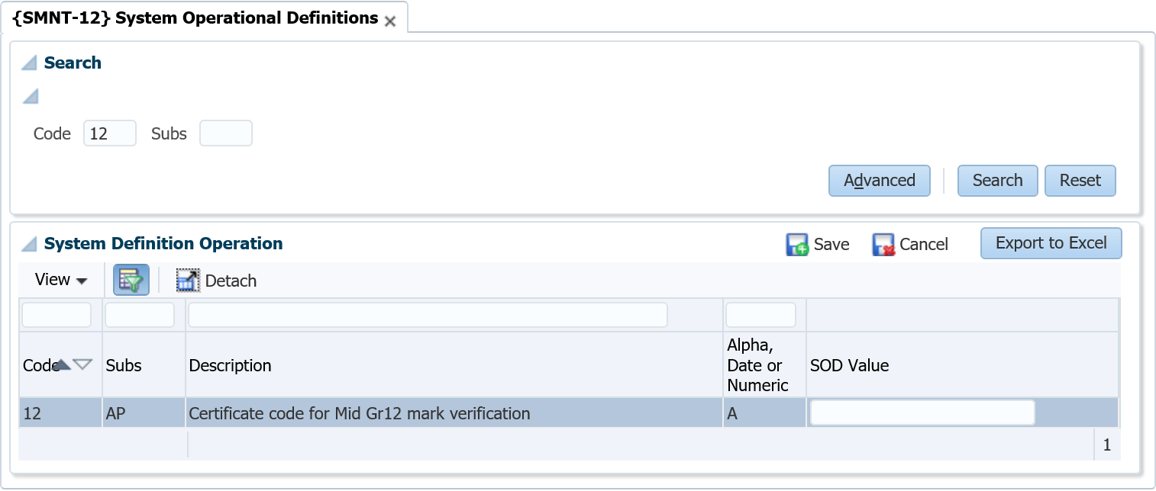

**Field Descriptions:**

**Code:** System pre-defined codes are the rules that are used throughout the student Sub-systems. These cannot be updated or created by users.

**Sub-System:** The rules that are indicated by the code in the "Code” field are valid for various student Sub-systems. The link between the rule and the system is pre-defined and cannot be updated by users.

**Description:** The description of the system pre-defined code defaults and cannot be updated by users.

**Alpha, Date or Numeric:** The value in this field indicates whether the Alpha/Date or Numeric field needs to be completed. If the value is (**A**)lpha or (**D**)ate the Alpha/Date field must be completed by the user. If the value is (**N**)umeric the Numeric field must be completed by the user. These values are pre-defined (per rule) and cannot be updated by users.

**Alpha/Date Field:** Supply the (**A**)lpha or (**D**)ate value for the rule specified. The value to be supplied is determined by the definition and purpose of the SOD.

**Numeric Field:** Supply the (**N**)umeric value for the rule specified. The value to be supplied is determined by the definition and purpose of the SOD.

| **SOD** | **SUB SYSTEM** | **DESCRIPTION** | **ALPHA, DATE or NUMERIC** | **USAGE** |
| --- | --- | --- | --- | --- |
| AP | RR | Allow part time students to register in a Residence | Alpha | If the value is set to 'Y' then a student can register in a residence for any type of offering type.  If the value is set to 'N' then a student can only register for a 'Full Time' offering in a residence.  **Note:** This rule is applied irrespective of the admission status of the student on the residence. |
| FS | RR | Enter the citizenship code that indicates National students | Numeric | The value here will be compared with the student's citizenship code in {SREGB-1}.  If the values are the same, the student will be seen as a "National" Student. If not equal, the student will be seen as a non-National student.  **Note:** This value is used in the application of the Residence Registration Rule "International" in {SRESIDE-2}. |
| FY | RR | Enter the qualification type where a level 1 period of study is considered a first year student | Numeric | This qualification type is used to determine the "first year" status of a student.   Only the period of study of any qualification linked via the approved qualification to this qualification type will be evaluated.   If the period of study is the "start" study period in the hierarchy defined in {SCODE-30}, it will be evaluated to level one of the hierarchy.  **Note:** This is a value that is used in the application of the Residence Registration Rule "Senior Student" in {SRESIDE-2}. |
| NS | RR | Enter number of required subjects for iEnabler Residence Registration in the numeric field | Numeric | This SOD is used on the student iEnabler Residence Registration.  A student will only be able to continue with residence registration if number of subjects entered on this SOD is greater or equals to number of registered subjects where academic year is equals to residence year.  If this SOD is NULL then a student will be able to continue with residence registration, number of registered subjects will not be checked. |

### Residence Quotas {SRESIDE-3}

**Quota information for Residences**.

The Building Code of the Residence will be used here for Quotas per Student Residence Type. Validation regarding the Space Category {SPOPS-1}, will validate for Residences where the Building code is linked to Aggregate Program = 9 on { SPCS-4}, for Space Category Codes between 1910 and 1918; 1920 and 1934; 1950 and 1954 and 1970

**Fields in this option:**

**Block 1: Quota Information For Residences**

**Academic Year:** The Academic Year of the residence registration/application is entered here.

**Residence Building**: Validation regarding the Space Category {SPOPS-1}, will validate for Residences where the Building code is linked to Aggregate Program = 9 on {SPCS-4}, for Space Category Codes between 1910 and 1918; 1920 and 1934; 1950 and 1954 and 1970.

Residence Type A1:

**F - First Year Student**: (First time Academic and Residence Registration/Application)

**S - Senior Student:** (Do have previous Academic and Residence Registration/Application)

**O - Other Student**: (Do have previous Academic Registration/Application but first time Residence Registration/Application)

**A** - All Student Residence Types

When A is entered, no other record for the year, building can be entered

When F, S or O is entered then A is not allowed.

**Quota:** Quota will be tested at Application and Registration not to allow more students in the residence as the quota.

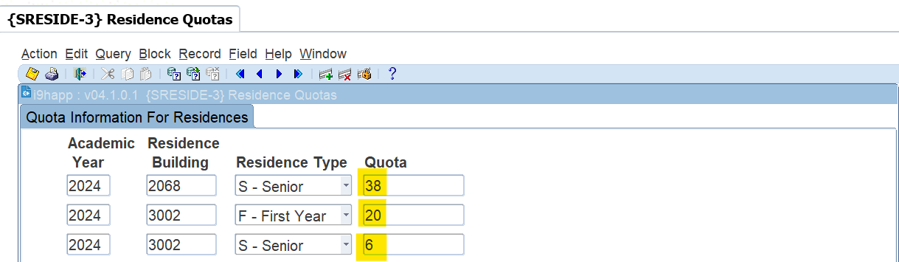

### Bulk Residence Admission {SRESIDE-16}

#### Ordering

Ordering will be done based on

* **Score** – one of the following
  + APS/WRS scores
    - First years. The WRS score can be calculated per academic application.
* **Average mark** 
  + Seniors and Others. Using results of (Application year -1). Excluding cancelled subjects and Exam only registrations.
* **Pass Rate**
  + Seniors and Others. Using results of (Application year -1). Excluding cancelled subjects and Exam only registrations.
* **Application Date**
  + Application Date
    1. Excluded students
* Currently excluding any active Actions **AR, RA, HA, HR,** and **H and R**.
* How do you know funding is available – the absence of financial stop status
* **Clients to provide any other statuses that should be used to identify Funded or non-Funded students.**
* Students will also be removed from the screen if the student balance is more than the ‘**Fee Account Balance**’ entered.
* Exclude Residence Status :
  + Admitted This option will exclude students that has an admission status that leads to ‘Y’
  + Registered This option will exclude students that are already enrolled for this residence
  + None This option will not exclude students
    1. Search Criteria

**Mandatory**

* Academic Year
* Residence Block
* Residence Building Code
* Residence Type.
  + Use A - ALL if ***no quotas have been set on {SRESIDE-3}***

**Then click on the Calc Performance button.**

**Students with statuses as mentioned here above will not display on the screen when you do your selection or bulk updates.**

It will then be depending on which residence code (7000) is selected display the following information as highlighted in yellow in the screen below and the example used:

* Quota (78)
* Mark Limit for Single room (70)
* Residence Type Quota (78)
* Residence Type Quota available (78)
* Registered (0)
* Admitted not yet registered (0)
* Overall bed count in residence (78)
* Students selected (0)

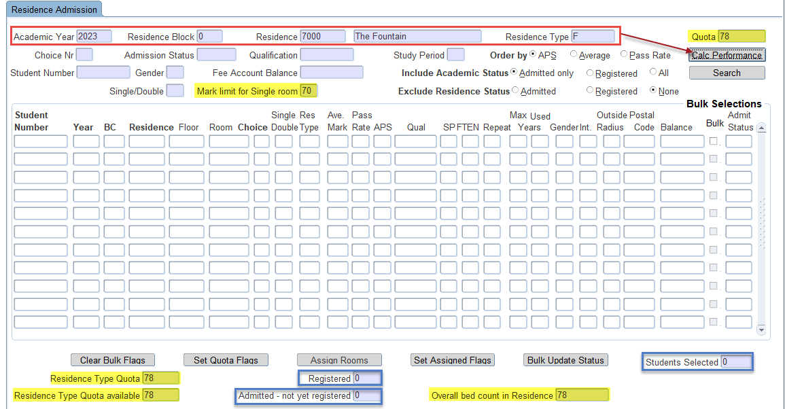

**Please keep in mind that the following fields is additional criteria that can be used to search for more specific or selective information.**

* Application Choice number
* Residence Admission Status
* Qualification Code
* Study Period
* Student Number
* Gender
* Fee Account Balance
* Include Academic status
  + Registered
  + Academic admitted. – These are students admitted but haven’t registered yet.
  + ALL
* Single or Double - Use 1 or 2 as valid values.
* Mark limit for Single room – default of 70. Students with average > this value will be assigned to single rooms. Value can be changed if the single rooms are not being allocated.
* Exclude Residence status
  + Admitted
  + Registered
  + None
    1. Quotas
* We suggest maintaining quotas on {SRESIDE-3} and allocating rooms based on residence types.
* Manually assigning quota values is possible and can be used as alternative if no setup done.
* Note it can be difficult to assign rooms for First years and Seniors at the same time since

the ordering of students cannot cater for both sets of criteria in the last first years do not have averages.

Fields on the Screen

* Residence type quota
  + Value from {SRESIDE-3} for the residence type in search block.
* Residence type quota available
  + Quota minus already admitted students for this building
* Registered
  + Number of residence registrations for this building
* Admitted – not yet registered.
  + Number of admitted students not yet registered.
  + If this value is negative – it means students were registered without having an Admitted application record with a room assigned.
* Overall bed count in Residence
  + Number of beds available in the residence
* Students Selected
  + This is a counter to indicate how many records have been ticked/selected.
    1. Buttons
* Calculate Performance
  + Press this button to calculate the average and pass ratios for all applications.
  + Save changes before continuing with assignment of rooms and admission otherwise you have to do the calculations again next time you work with this building.
  + Cycle P has to be open to allow any changes.
* Search
  + Same as Next Block.
  + Query students based on search criteria and order by selection.
  + The Search action will not pre-select students.
* Clear Bulk Flags
  + Clear all tick boxes.
* Set Quota Flags
  + Use this button after you have queried the students.
  + Selects all tick boxes based on ‘Residence Type Quota available’ value that is determined by the quota predefined per Residence Type on {SRESIDE-3}.
  + Selection will be done from top to bottom – based on the chosen order by
  + Quota can also be set manually if quota is not setup on {SRESIDE-3}
* Assign Rooms
  + Works only with student numbers that has been selected/ticked.
  + Starting from Single rooms – it will match a room with a student number and populate the Floor and Room fields. The Single/Double field will also be updated.
  + No change will be made to students that have been admitted already. The floor and room is required before a student can be admitted.
  + Cycle P has to be open to allow any changes.
  + Single rooms will be assigned to senior students with average > 70%
* Set Assigned Flags
  + Use this button after you have assigned the students.
  + Use this button if you want to auto select all records with a Floor and Room in order to update the admission status in bulk.
* Bulk Update Status
  + Pressing this button will display a popup to allow user to update admission status of all selected students.
  + Cycle P has to be open to allow any changes.
    1. Detail Fields
* Student Number Applicant Student number
* Year - Application Year
* BC - Application Block
* Residence - Application Residence
* Floor - Application Floor
* Room - Application Room
* Choice - Application Choice
* Single/Double - value of 1 or 2
* Res Type - value of S-Senior/O-Other/F-First year
* Ave Mark - calculated from previous year results
* Pass Rate - calculated from previous year results
* APS - calculated based on matric results
* Qual - Qualification student registered for – and if not registered already

then display the application qualification.

* SP - Qualification Study Period
* FTEN - Students FTEN indicator
* Repeat - Y – if student is repeating the Qualification and Study Period
* Max Years - Formal time of qualification. 99 indicates SOD S6/RR is set to N
* Used Years - Number of years student has been academically enrolled
* Gender - Student gender
* Int - Student is Foreign – Y-Yes, N-No or P – Permanent Resident.
* Outside Radius - Y – if student postal code falls outside 50km radius.
  + - * + Please provide all towns/campuses where there are residences. We need to manually determine the postal codes to use to do this calculation.
* Postal Code - The postal code on the students Physical Address. If no Physical Address then the postal

code from the primary postal record.

* Balance - Student Balance
* Bulk - Tick box to select students
* Admit Status - Residence Admission status. Can be updated manually or in bulk.

**Then click on the Search button.**

It will now display the following student information by ordering the **APS**:

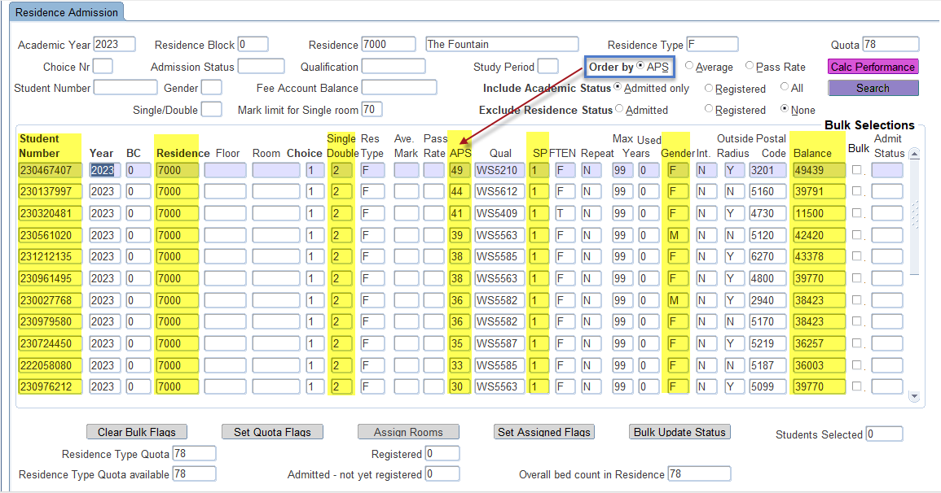

Added criteria = **Gender = F**

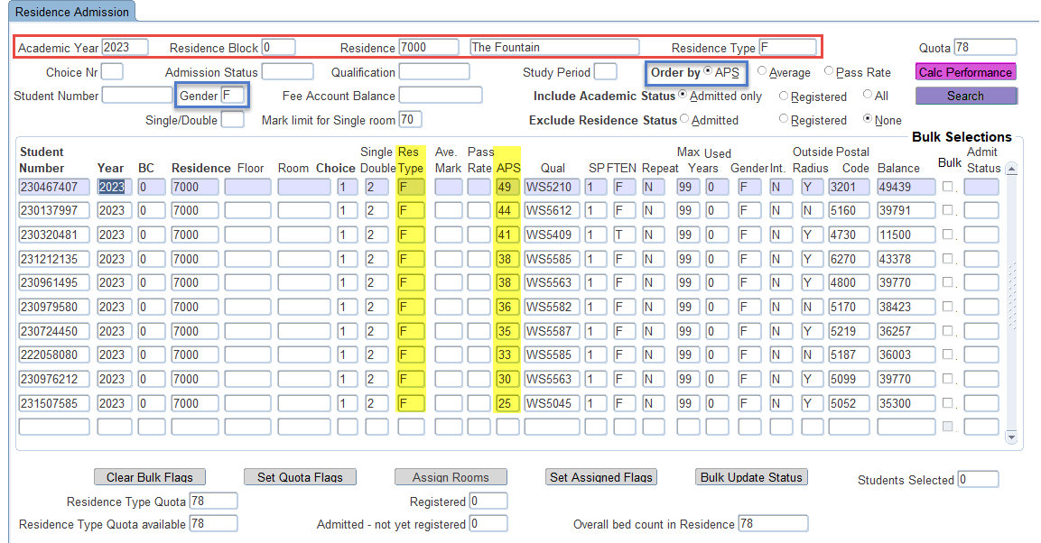

**Click on the Set Quota Flags button.**

In this action the system will tick all the bulk boxes as indicated in green for those students as priority.

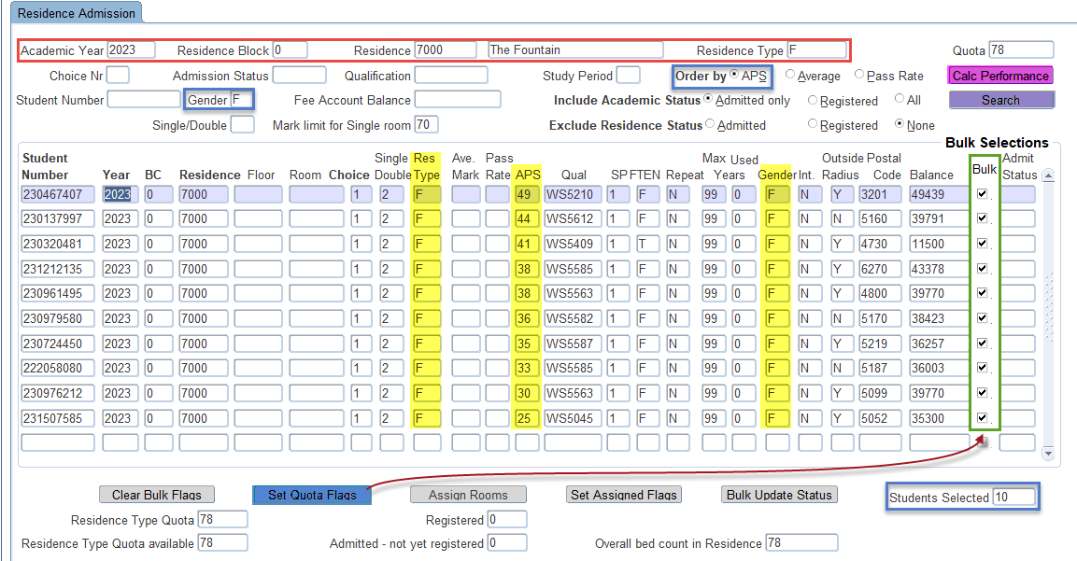

**The next step is to click on the Assign Rooms button**. The system will now assign rooms available to the students that qualify. At this point the user can still make changes or adjust.

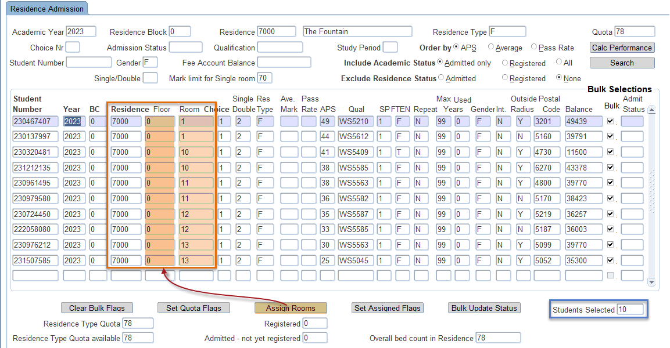

Once the user has accepted the assignments or has adjusted the records, **they can click on the Set Assigned Flags button** to prepare it to be saved. It will also display the number of records that will be selected (9).

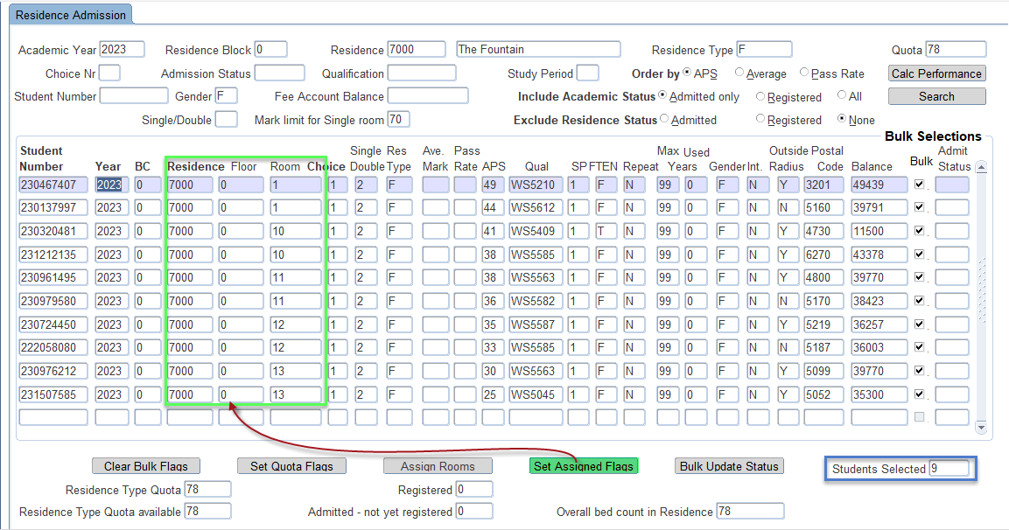

The user or residence officer will now have to **SAVE the records** first before a bulk update of status can be performed. You will notice that it displays 10 records have been saved.

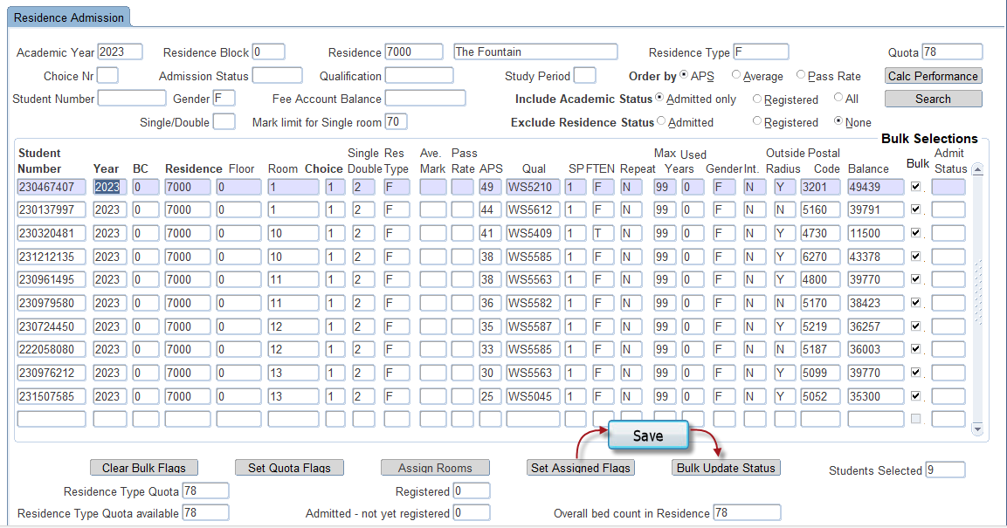



Then the user or residence officer **can click on the Bulk Update Status button**. It will display another pop-up screen where the user needs to enter the **R1** admission status.

**Then click on the Update button.**

If the user does not want to save or update the records he/she can click on the **Exit without Updating** button.

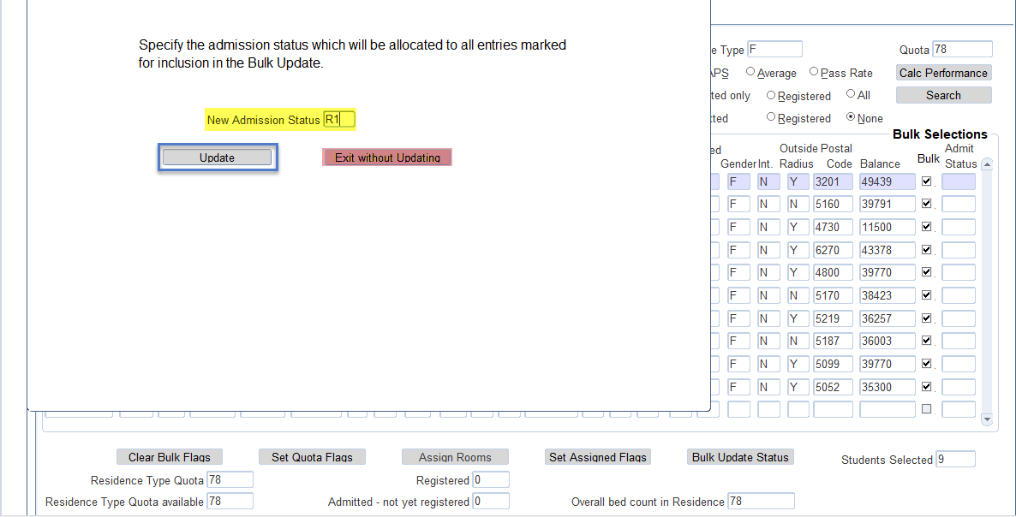

When the user does click on the Update button it will ask you to confirm your update as can be seen here below.

Click on the “**Yes**” and the records have been saved.

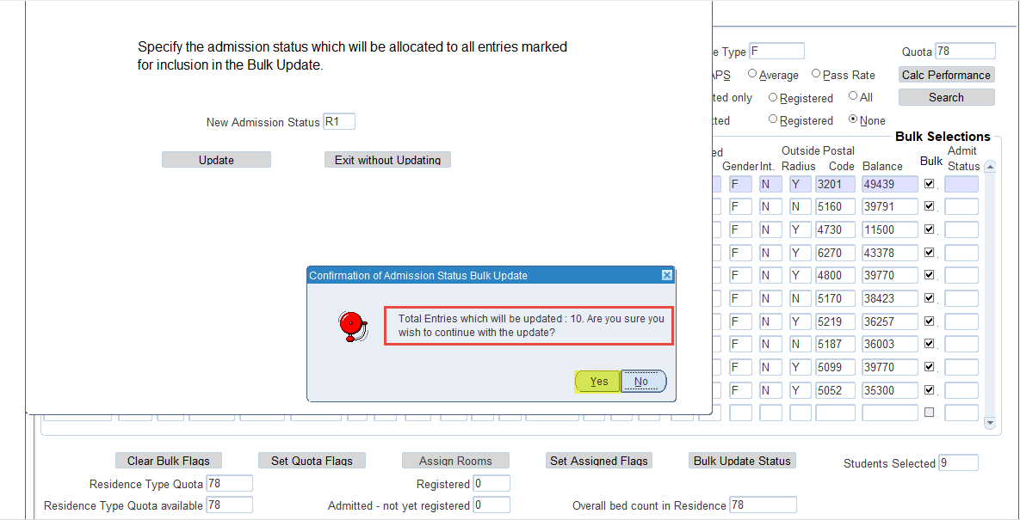

**Below you can see the records saved with the R1 status.**

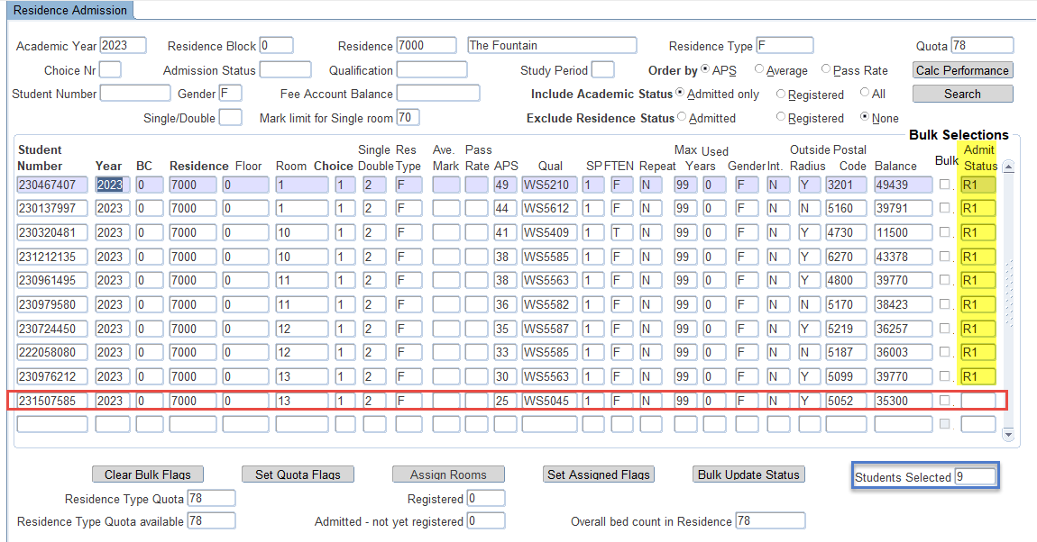

Below is reports that can be used. Please check them out.

The student will also receive a notification once he/she has been admitted.

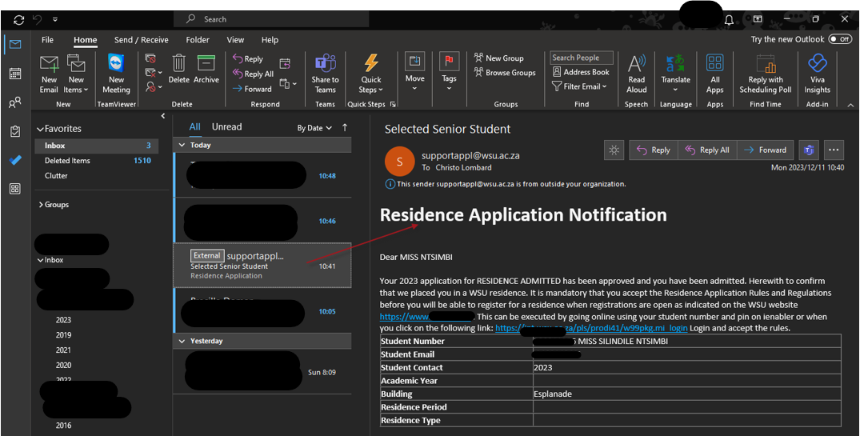

### Residence Registration Rules {SRESIDE-2}

This option is used to define rules against which students will be tested when registering or applying for a place in the residence.

**Note:** Both the Import and Export functionalities are enabled in this option.

**Block 1: Residence Registration and Application Rules**

Before the user defines the content of the rules in Block 1, the user **must** define active rules in Block 2. Most of the fields in Block 1 pertaining to data elements can be left blank. It simply means that the particular data element does not play a role when evaluating the student’s attempt to register.

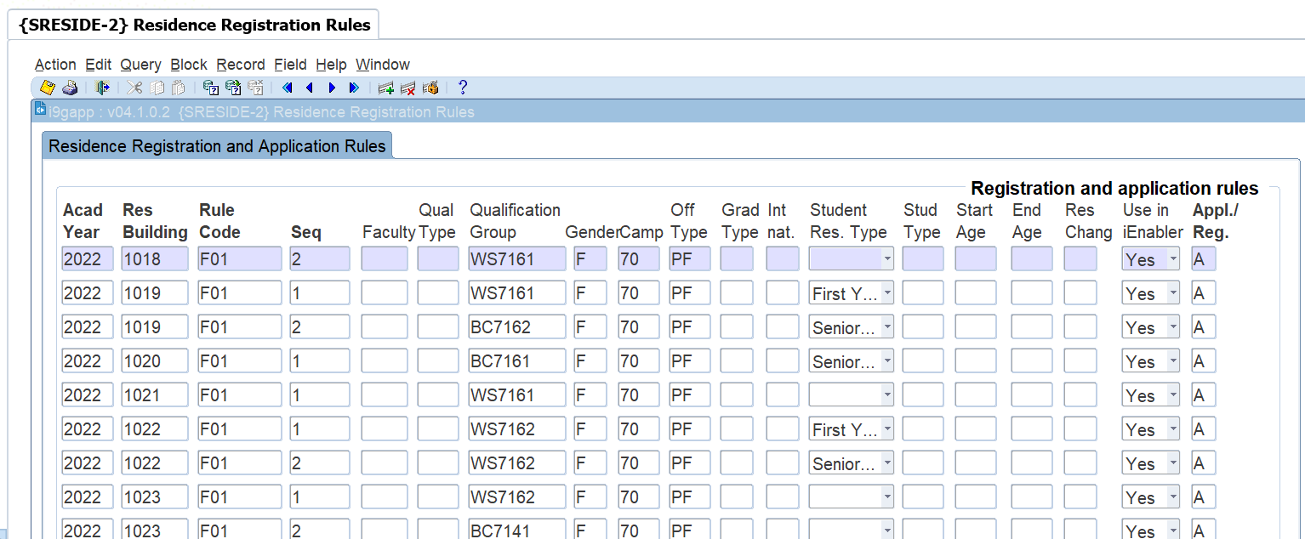

**Field Descriptions:**

**Academic Year:** Enter the Academic Year for which this rule will be valid. The LOV shows a distinct list of years from the Qualification definition in the Academic Structure.

**Residence Building:** Enter the residence building code. The LOV shows all building where the Aggregate Program is 9 and at least one venue in the building is linked to category 1900 to 1999 (excluding category 1919).

**Rule Code:** Enter the rule code for the Residence and year. Only active rule codes can be entered.   
If a record exists for a rule that has become inactive, the program will warn the user when a data element for the record is updated.

**Sequence:** Enter a sequence in which the rules will be applied for this year, residence and rule code. With this feature, it is possible to, for example, to define multiple qualifications that should be grouped in the same residence.

**Quota:** Enter the quota for this rule and sequence. The program will check that the total quota for all rules for a residence does not exceed the total number of places available in the residence.

**Qualification Type:** Enter the Qualification Type that will limit students for this rule. If a qualification code is already entered in the next field, the program will check that the qualification type matches the qualification type linked to the qualification.

**Qualification:** Enter the qualification code that will limit students for this rule. If a qualification type code is entered in the previous field, the program will check that the qualification type linked to the qualification matches the qualification type entered.

**Gender:** Enter an 'F' or 'M'. This determines the gender of students allowed for this rule.

**Campus:** Enter a campus where the student's academic registration will be. If an Offering Type exists in the next field, the program will validate that the offering type is linked to the updated campus.

**Offering Type:** Enter an offering type that will be matched to the student's academic registration. If a campus were entered in the previous field, the program will check that the offering type is linked to the campus entered.

**Grad Type:** Enter the graduate type allowed with this rule. Enter a 'U' for Undergraduate and a 'P' for Post Graduates.

**International:** This field is used to indicate if only International students can comply with this rule or only National students. A 'Y' indicates that International Students are allowed and an 'N' indicates that National Students can register under this rule.  
To determine if a student is national or international, the SOD 'FS' (Enter the citizenship code that indicates National students) for subsystem 'RR' as defined in {SMNT-12} is used. The user must enter a Citizenship code that will be deemed a National student.

**Senior Students:** This field is used to indicate if only Senior Students or only Junior Students may register in the residence.   
A student is considered a junior student if the level of his/her period of study = 1.   
The level of the study period in the hierarchy of the definition of the study periods in {SCODE-30} will be 1 if there is no "Previous Period" in the hierarchy.   
To further refine this test, the user can enter a Qualification Type in SOD 'FY' for subsystem 'RR' in {SMNT-12}.

**Student Type:** Enter the student type that a student must have to register in the residence.

**Block 2: Residence Rule Definition**

This block is used to define the rule codes that are used in the detail of block 1.

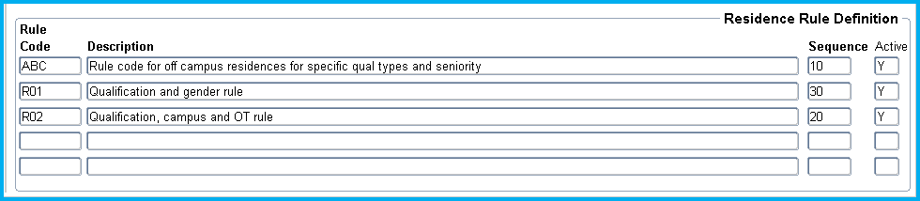

**Field Descriptions:**

**Rule Code:** Enter a code that will identify a Residence Registration Rule.

**Description:** Enter a description for the Rule Code

**Sequence:** Enter a sequence number for this rule. This number determines the sequence in which the rules will be applied to a student's Residence Registration

**Active:** Enter a ‘Y’or ‘N’ to indicate if the Rule Code is active.  
Only active Rule Codes can be used in block one. If, however, a record exists in block one and is made in-active in this block, the rule will not be applied when evaluating a student's registration in the residence.

### Processing Rules

This program does not perform any special processing rules. The following is a high level description of how the rules are applied in the iEnabler Residence Registration. The description is based on the data in the example above.

The Residence Rules in Block 2:

* The rules will be applied in the following sequence: ABC, then R02 and then R01 because of the sequences linked.
* All the rules are active and will be applied for every residence it is linked to.

The Rule details:

* As can be seen in the example, a single residence can be linked to multiple Rule Codes and each can have multiple data elements that should be tested.
* Rule ABC sequence 10 allows
  + One International student to register in residence 1000 for 2012
* Rule R02
  + Sequence 10 allows
    - 3 students that are registered for qualification BCLOTH (the Qualification Type and Grad Type is really redundant in this example),
    - offering type 01 (again the campus code 19 is redundant),
    - is an International student
    - is a Senior student to register in residence 1000 for 2012
  + Sequence 20 allows
    - 2 male senior students irrespective of their qualifications, campus, offering type or student type to register in Residence 1000 for 2012
* Rule R01 allows sequence 20 allows
  + 4 students that are
    - Female
    - registered for the qualification DSPORT
    - to register in residence 1000 for 2012

**MODULE**

**2**

# **Residence Application Function**



Specific outcomes

On completion of this module, you will be able to:

* View/Update Personal Information
* Accept the Residence Rules and Regulations
* Submit Residence Application
* Cancel Residence Application

This option allows prospective students to apply for residence admission via the Student iEnabler. The student may apply for:

* + Year
  + Residence Period
  + Building ({SPCS-4}, Category = 9)
  + Room Type (Single / Double)
  + Choice

If a student should receive a contract from the institution, {STWEBM-7} should be set up to insert a certificate code on the student record on {SREGB-8}. This will be done on clicking on the ‘I Accept’ button. A certificate code as defined in {SCODE-22} must be linked to {STWEBM-7} Event Code ‘B2’. A record will be inserted in {SREGB-8} with an indicator seen set to ‘No’

Financial transactions are raised in {SNAPPA-2}.

**Note:** If a process is mandatory, it must be completed **before** a student’s application can be completed.

# **View/Update Personal Information**

The student can view and/or change his/her Biographical detail via the web. If the Dynamic Biographical process is used, only fields that are marked for update can be updated as defined in {STWEBM-5}.

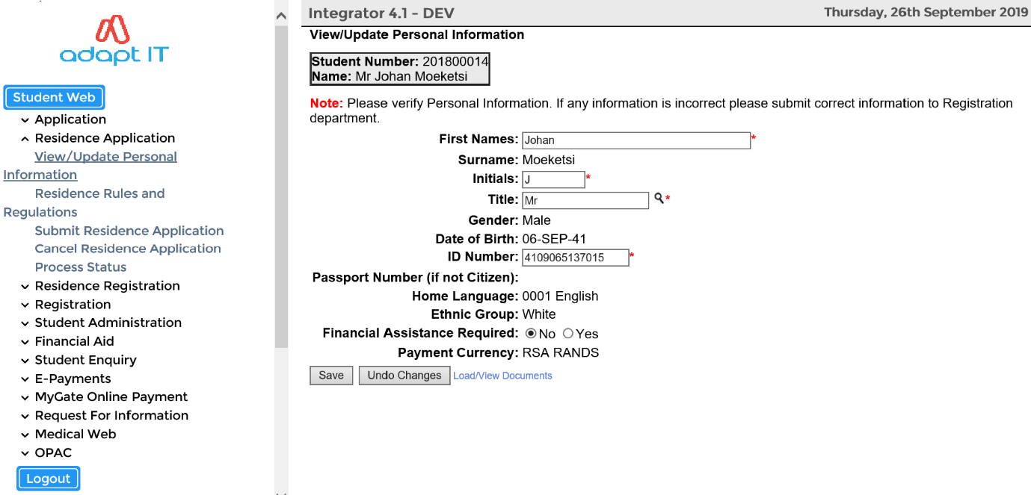

# **Residence Rules and Regulations**

The Process Event code ‘B1’ (Residence Application Rules and Regulations) as defined in {STWEBM-7} is used.

* A document code can be created in {SLLL-1} and linked to Event Code ‘B1’.
* A document can also be added as an HTML or PDF FORMAT {Business Function and Process}

The student can read the criteria/rules for residence application. If the student accepts the rules he/she can click on the “I Accept” button.

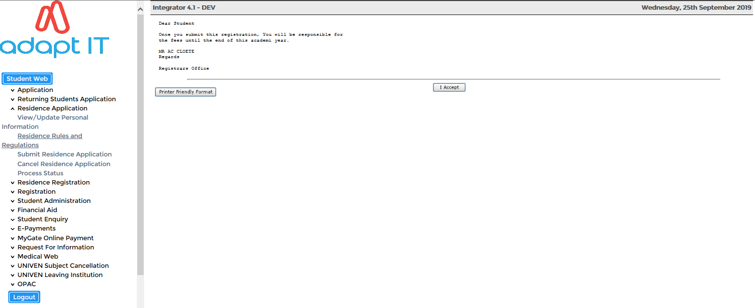

The following screen will appear to inform the student that his acceptance of the application is logged.

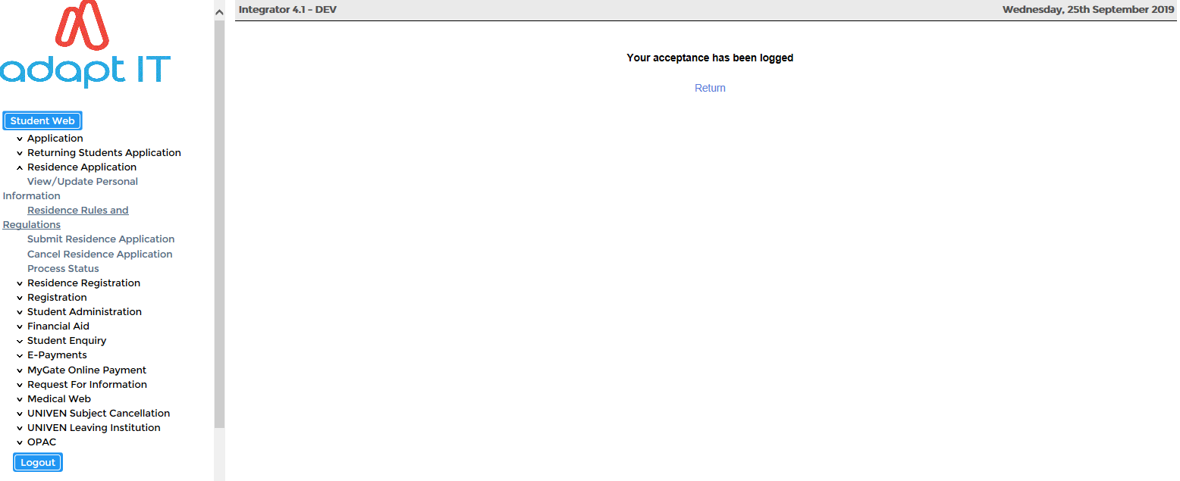

# **Submit Residence Application**

The student will be able to process his/her Residence Application via the Student iEnabler system.

The Process Event code ‘B2’ (Residence Application Certificate Indicator) as defined in {STWEBM-7} is used.

A Certificate code as defined in {SCODE-22} must be linked to Process Event Code ‘B2’. A record will be inserted in {SREGB-8} with an indicator seen set to ‘NO’.

The following information is required:

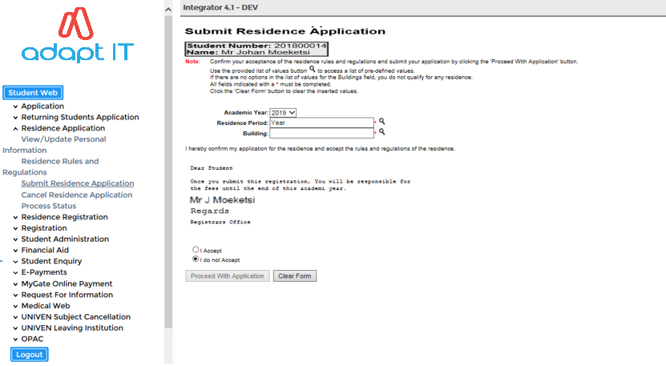

**Field Descriptions:**

**Calendar Year:** The year for which the student is applying

**Residence Period:** The LOV will display all valid Residence Periods

**Building:** The LOV will display all valid Buildings

The student then has the option to either “Proceed with the Application” or “Clear Form”. Once the student proceeds with the process the screen will be displayed.

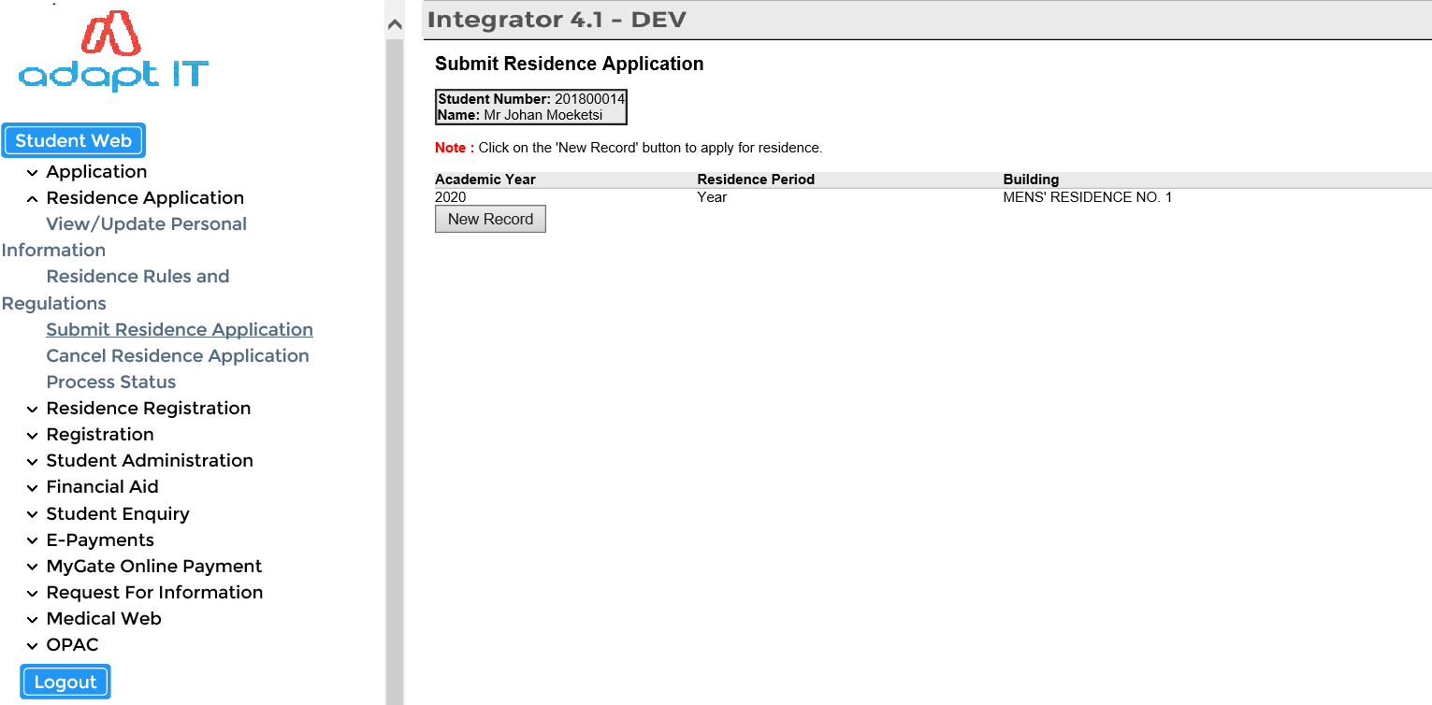

# **Cancel Residence Application**

If the student wants to cancel the residence application, a cancellation reason needs to be selected from the LOV and “Save” the record.

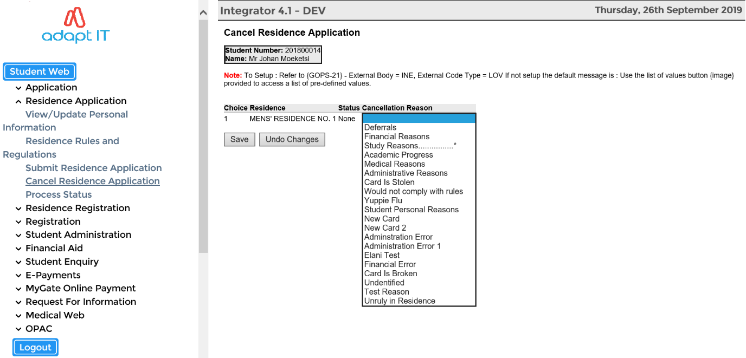

**MODULE**

**3**

# **Residence Registration Function**

Specific outcomes

On completion of this module, you will be able to define the following processes:

* Residence Registration Rules and Regulations
* Submit Residence Registration
* Residence Proof of Registration
* Proof of Residence

* 1. **Residence Registration Rules and Regulations**

The Process Event code ‘B4’ (Residence Registration Rules and Regulations) as defined in {STWEBM-7} is used.

* A document code can be created in {SLLL-1} and linked to Event Code ‘B4’.
* A document can also be added as an HTML or PDF FORMAT {Business Function and Process}

The Residence Registration process for a student will look as follows:

* If required, the student must click on the “I Accept” button for “Residence Registration Rules and Regulations”

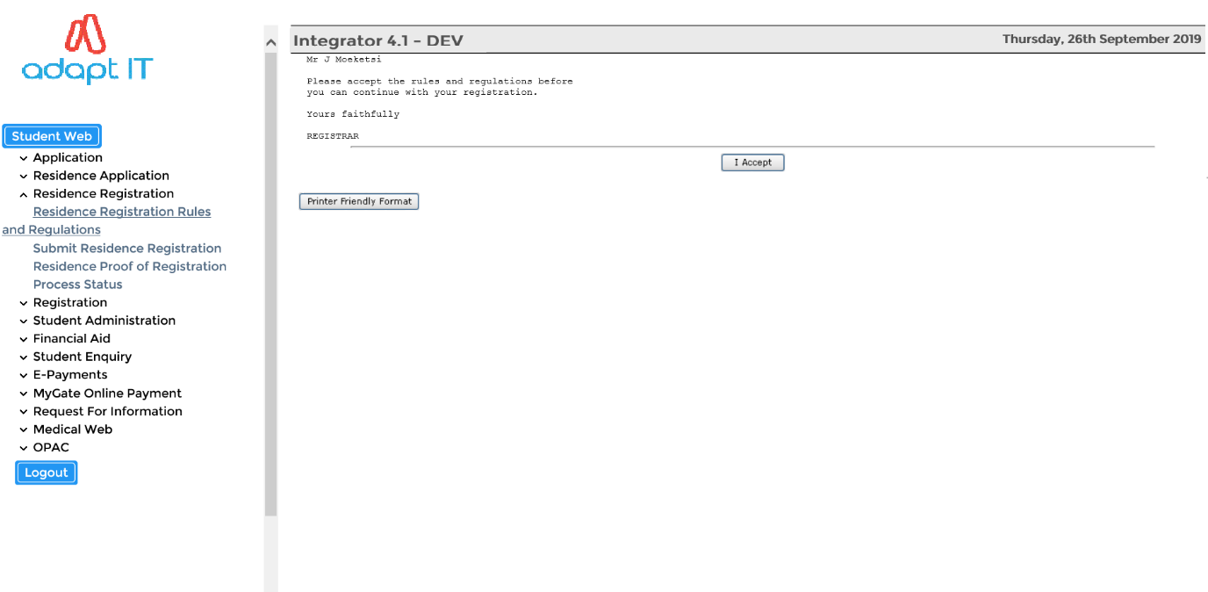

The following screen will appear to inform the student that his acceptance of the application is logged.

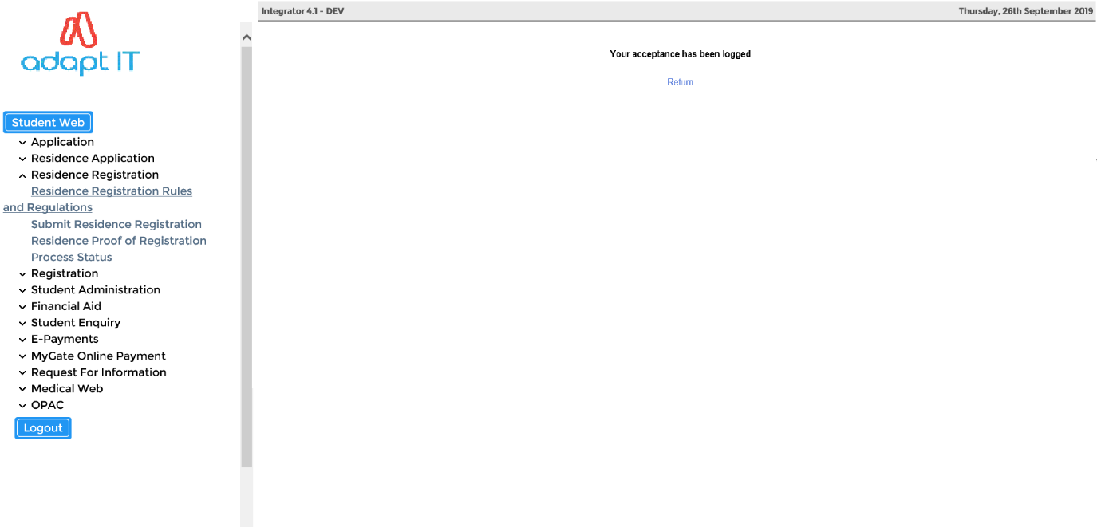

* 1. **Submit Residence Registration**

The student will then click on the "Submit Residence Registration" option and may find any of the following responses;

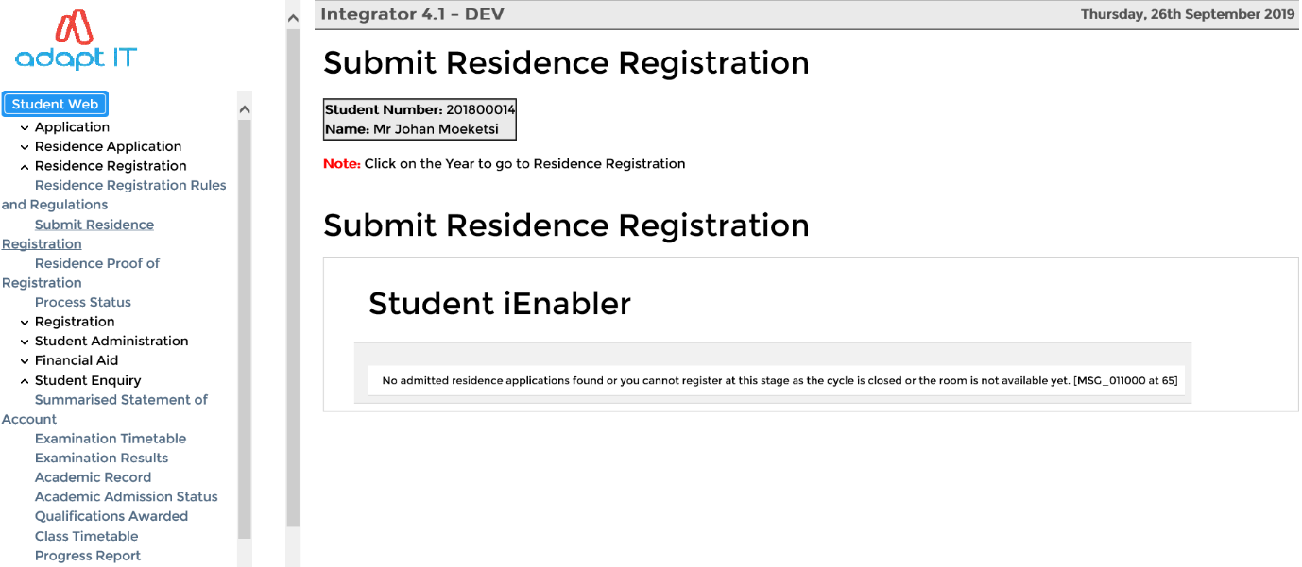

**Error Message:**

*No admitted residence Applications Found, or you cannot register at this stage or the room is not available yet.*

**The cause for this message:**

The student is not admitted to a venue (**building, floor and room**) in a residence in {SNAPPA-4}

* The system cycle '1' is not open in {SMNT-2}
* The room is not set to active in {SPOPS-1}

**Error Message:**

*You no longer comply with the rules of the residence where there is not a hyperlink on the year. You can therefore not register in that residence.*

**The cause for this message:**

* The rules of the residence were changed in {SRESIDE-2} between admission and registration.
* The student no longer complies with any of the rules for the particular residence.

**Error Message:**

All places in the residence have been allocated. You can no longer register in the residence.

**The cause for this message:**

* The available stations (i.e. beds) as defined in {SPOPS-1}, have been allocated after admission of this student and this student is trying to register.
* This means that the quota for the rule (as defined in {SRESIDE-2}), that the student possibly passed, has been reached.

When ALL error messages have been cleared the student can proceed with the residence registration.

**Residence Registration Steps:**

* The student clicks on the year with the hyperlink and is presented with the registration screen
* The only field that the student can update is the ‘Date In’ field
* The cost for the residence registration is displayed (Fees as defined in {FSAM-1})
* The student will click on the "**I Accept this Registration**” button for the record to be processed.

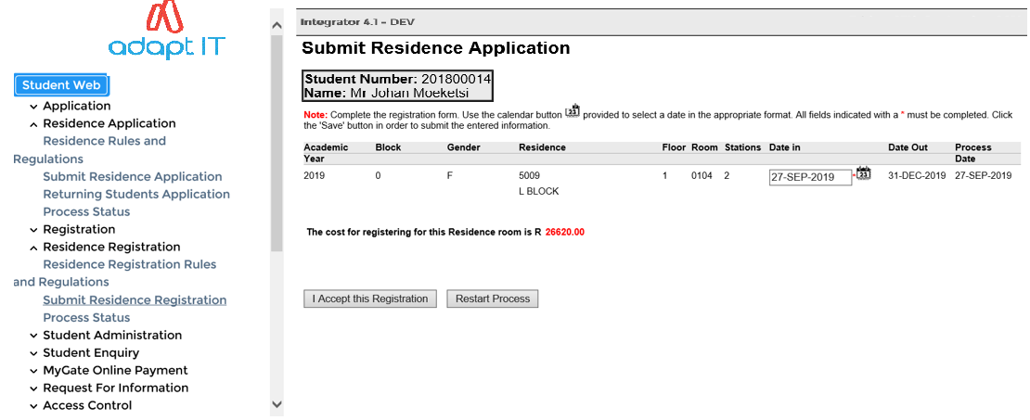

**After accepting the registration:**

* Once the student click on the "I Accept this Registration" button, a confirmation message will be displayed to the student.
* The student will be returned to the start page of Residence Registration function
* All the records will have a year without a hyperlink because the student is now registered.

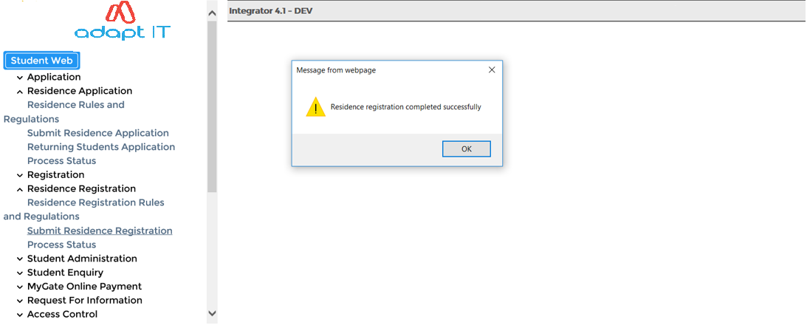

**Note:** It can happen that before the student clicks on the "**I Accept this Registration**" button, the room has been fully occupied i.e. other student(s) has registered in the room (clients do over admit because of students not pitching).

If the room is fully occupied, the student will get the following message:

* *‘This Residence Room is Already Fully Occupied’*

If the student is already registered in the residence and there are no other admitted residences the student will get the following message:

* *‘If the year in the records above does not display with a hyperlink, you are already registered in the residence’*

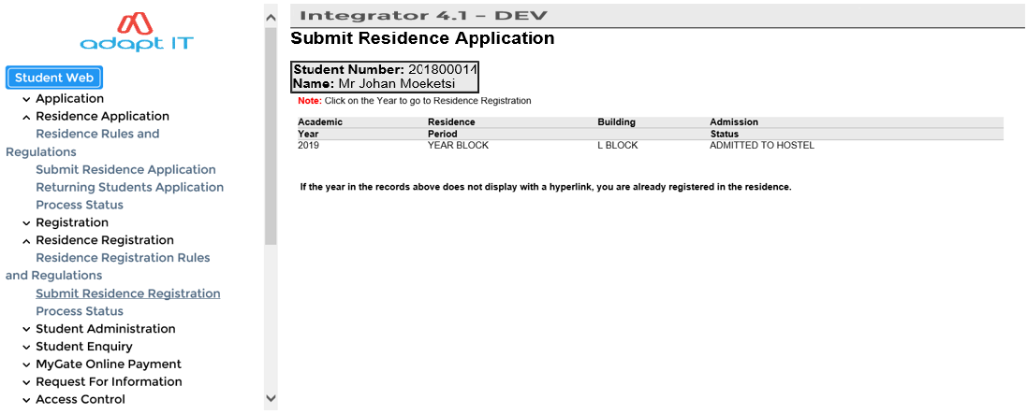

* 1. **Residence Proof of Registration**

The student can now click on the "Residence Proof of Registration" to get a nicely formatted document of a proof of his/her registration

**Very Important**: The batch queue W1 **must be open** for the student to get the document in the iEnabler.

The batch queues are maintained in {BATCH-3}. If the queue was open and the Application Server was restarted, the queue must be closed and reopened.

If the queue is not open, the student will get a message stating the document cannot be produced and the batch request number is displayed.

If the queue is open the student will receive a document that might look like this:

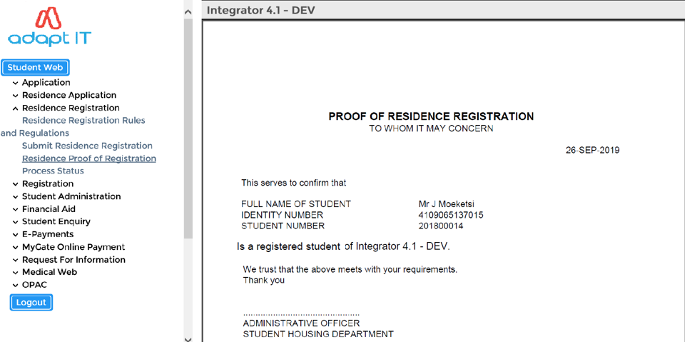

This document is an iComms document and the client can set up their own document and link it to the default group I1801GRP in {GMNT-5} or {GMNT-14}.

**MODULE**

**4**

# **Student Enquiry Function**

Specific outcomes

On completion of this module the following process is defined:

* Residence Admission Status
  1. **Residence Admission Status**

The user may view the progress of Residence Application if the ‘P’ Residence Application cycle is open on {SMNT-2}.

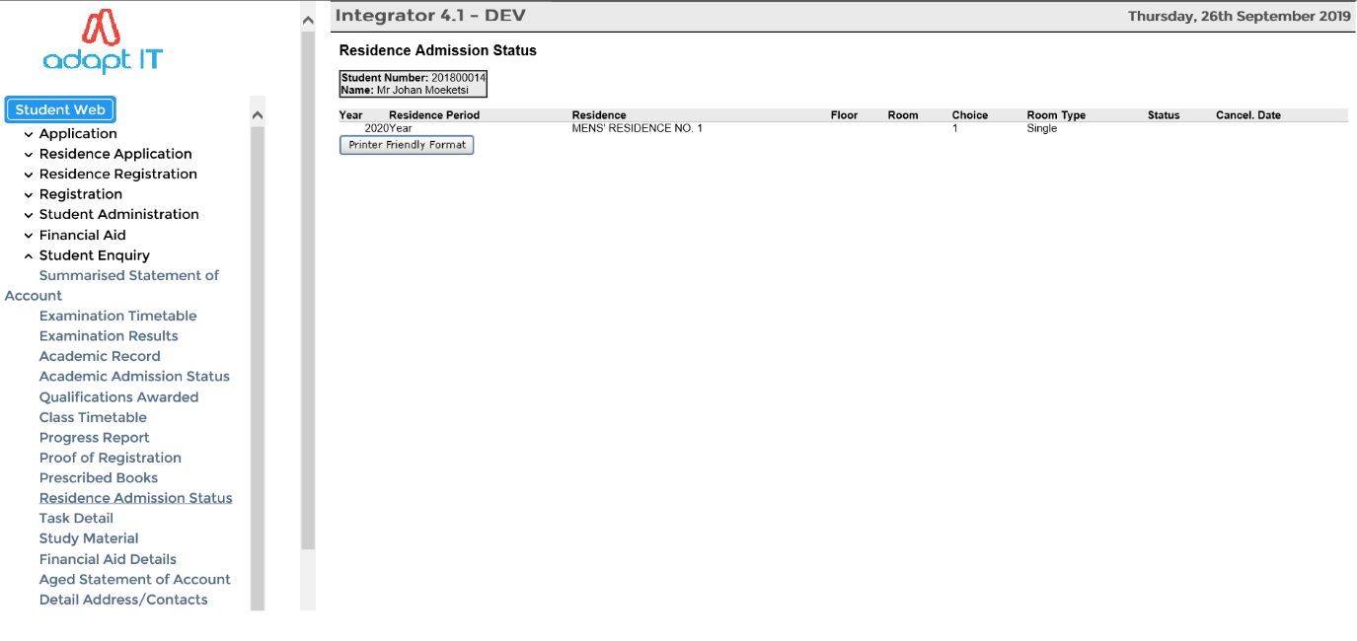

The record of the student residence admission status can be printed.

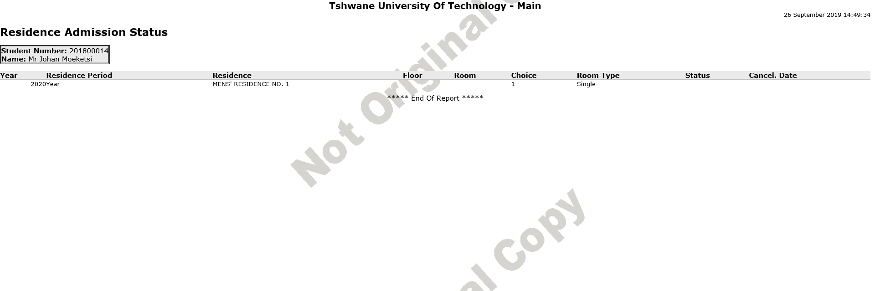

Other business processes can be viewed if the client set it up.

**MODULE**

**5**

# **Operational Issues**



Specific outcomes

On completion of this module, you will be able to:

* Login to the iEnabler
* Change Pin
* Request Pin

**How to log in:**

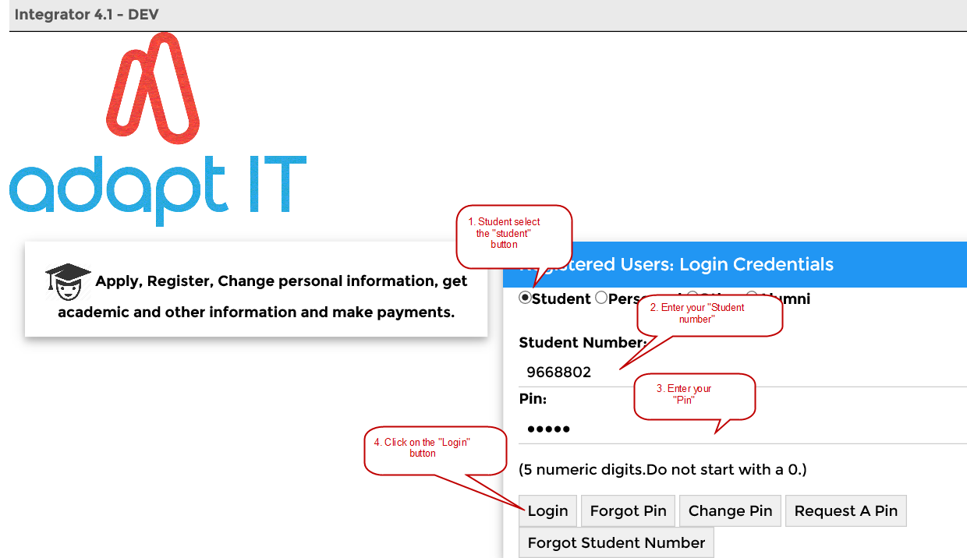

The following basic step can be followed:

* Student selects “Student” button
* Enter your “Student number”
* Enter your “Pin” and
* Click on the “Login” button.

**Forgotten your “Pin”?**

Click on the “Forgot PIN” button and the next screen will confirm that your PIN was successfully requested, and it was sent to your E-mail address.

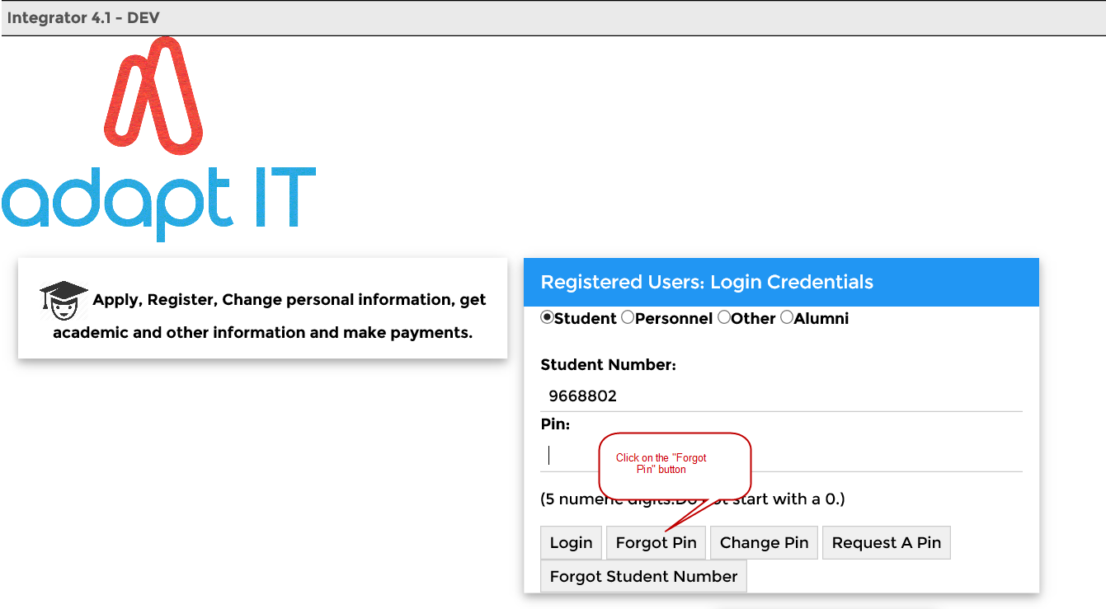

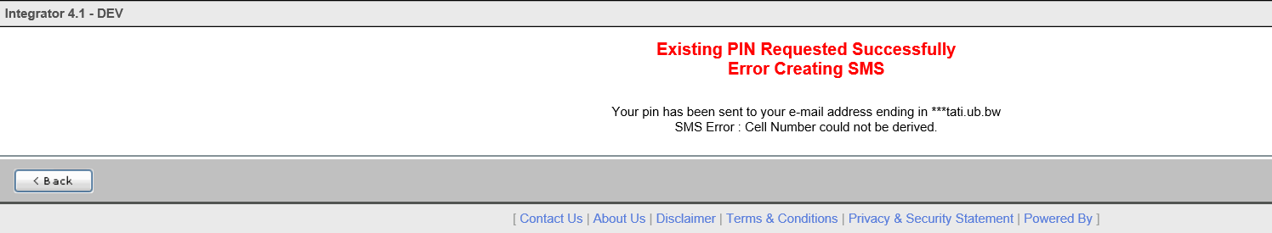

The message as it will appear on your Outlook.

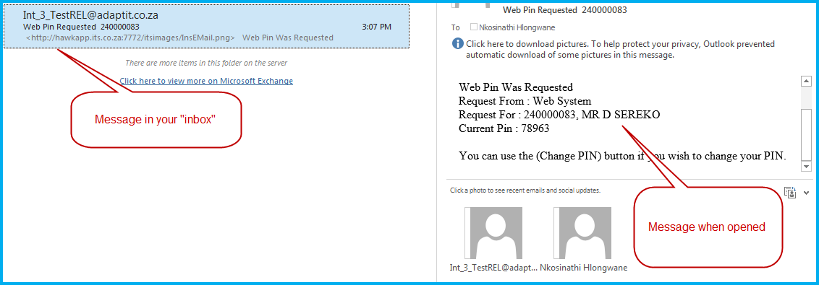

**Change “PIN”**

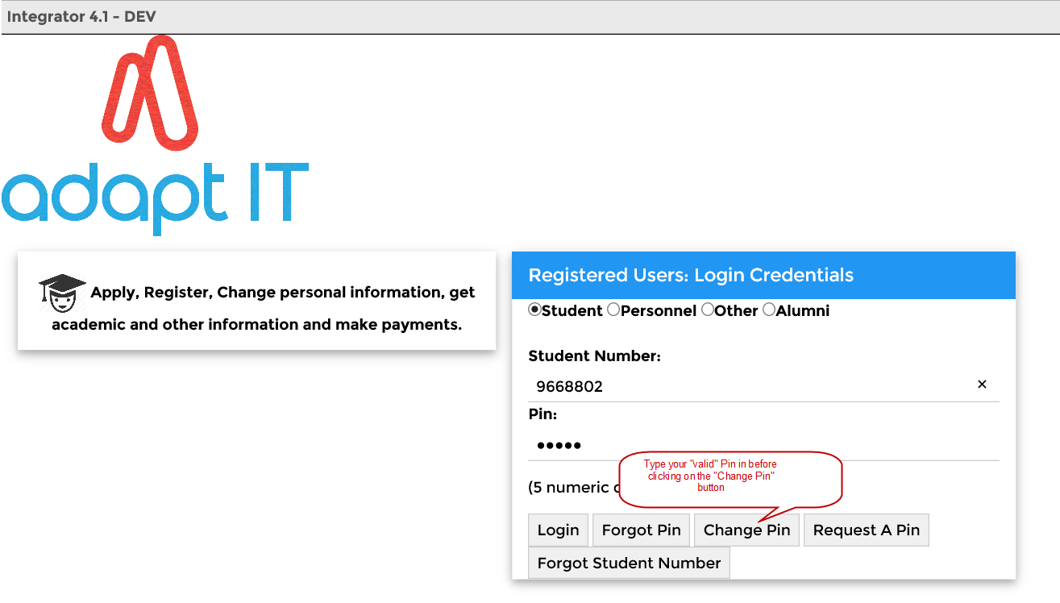

Remember to enter your valid PIN before you change your PIN.

* Then click on the “Change PIN” button. The following screen will appear where the pin is being changed for the person involved.
* The “New Pin” is entered.
* Verify the “New Pin”.
* Now click on the “Change pin” button. (See screen below)

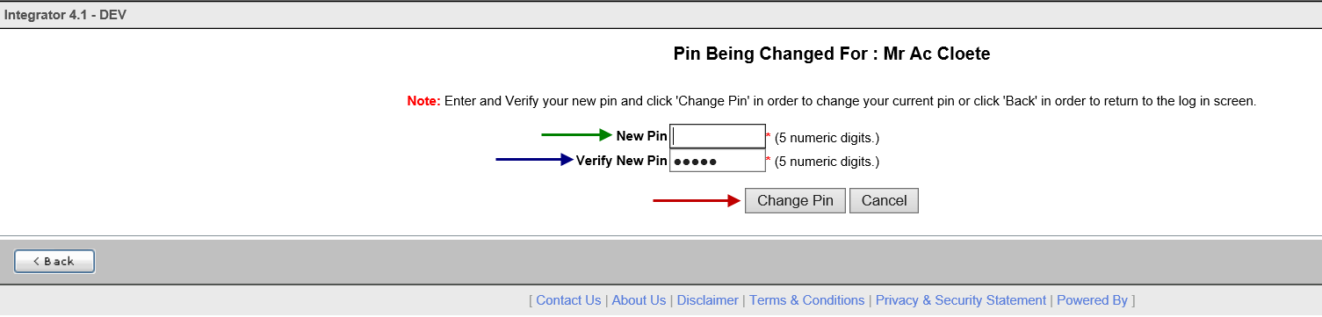

As soon as the “Change Pin” button is clicked on, the system will allow you to continue.

You will also receive an e-mail that your pin was requested. See the print screen below.



**Request a pin**

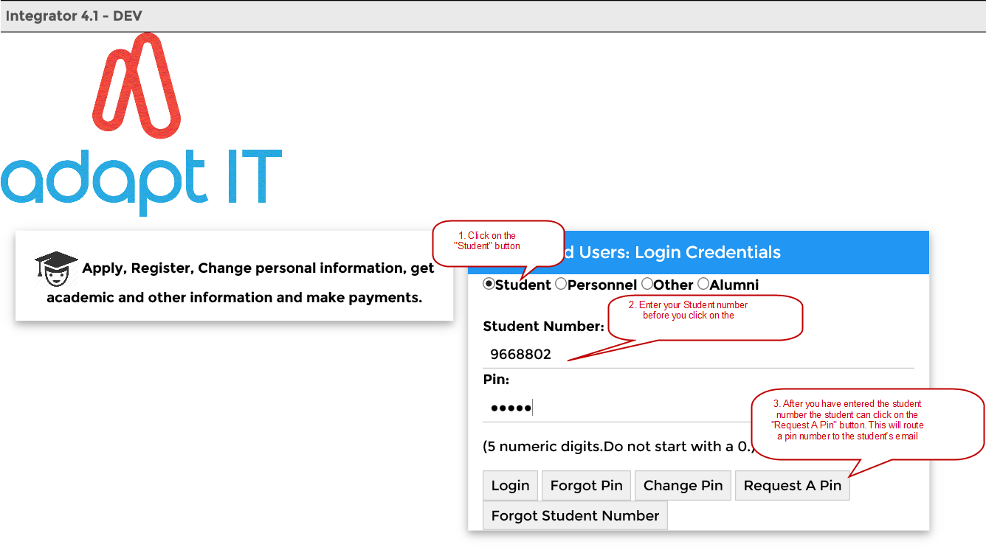

Click on the “Request a PIN” button and the next screen will confirm that your PIN was successfully requested and it was sent to your E-mail address.



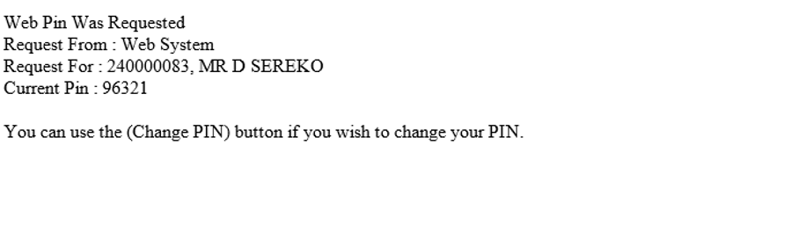

**MODULE**

**6**



# **Residence iEnabler Implementation – Responsible User**



| Code Structure | Section | Responsible User | Due Date |
| --- | --- | --- | --- |
| STWEBM-1 |  |  |  |
| STWEBM-2 |  |  |  |
| USERS-1 |  |  |  |
| STWEBM-7 |  |  |  |
| SMNT-1 |  |  |  |
| SMNT-2 |  |  |  |
| SRESIDE-2 |  |  |  |
| SMNT-12 |  |  |  |
| GOPS-1 |  |  |  |
| GOPS-21 |  |  |  |
| BATCH-3 |  |  |  |
| FSAM-1 |  |  |  |
| FSAC-21 |  |  |  |
| AOPS-1 |  |  |  |
| GMNT-14 |  |  |  |
| SRESIDE-2 |  |  |  |
| USERS-11 |  |  |  |
| SPOPS-1 |  |  |  |
| GCS-5 |  |  |  |
| SACAD-13 |  |  |  |
| SCODE3-1 |  |  |  |
| SLLL-1 |  |  |  |

**Interface Manual**

Copyright

©All rights reserved

No part of this document may be reproduced or transmitted in any form or by any means, without express written permission from Adapt IT or an authorised representative of Adapt IT. This includes, but not limited to, electronic, electrostatic, magnetic tape or mechanical copying and recording, or use of any information storage and retrieval system.

First edition: February 2018

Disclaimer

Adapt IT makes no representations or warranties with respect to the contents hereof. Although due care and precaution has been taken in the preparation of this manual, Adapt IT assumes no responsibility for errors and omissions or any damages resulting from the use of the information contained in this publication .

**Contents**

Course Overview 1

**Layout** 1

**Module Structure** 2

1 System Access 3

1.1 Screen Resolution 3

2 Log in page 4

3 Integrator Entry Screen 7

3.1 Landing page 7

3.2 Navigation to a menu option 9

3.3 Adding Favourites 11

4 Accessing online help 12

5 Accessing the Work list and Batch process 13

5.1 Introduction 13

5.2 Running a batch program 13

6 Reports 15

6.1 Introduction 15

6.2 Jasper Reports 15

7 Forms 17

7.1 Introduction 17

7.2 Specific Rules Related to Forms Programs 18

7.3 Specific Rules Related to Forms Programs 19

8 Screen Patterns 20

8.1 Introduction 20

8.2 Entry Point (EP) 20

8.3 Simple Codes Table (TCS) 21

8.4 Table with Search Panel (TCM) 21

8.5 Multiple tables/Columns with Search Panel (TCL) 22

8.6 Search panel with results in query-only table (TQ) 24

8.7 Search panel with results in query-only tree table (TT) 24

8.8 Search Panel, Search Results Table with CRUD Form at the bottom(FCM) 25

8.9 Search Panel, Search Results Table (one or more) with pop-up CRUD Form (FCM-PC) 26

8.10 CRUD Form with Search pop-up or Search Panel (FCL) 27

8.11 Search Panel with Search Result Table and CRUD Form on different page (FCL-TSL) 27

8.12 Create only Form (FCO) 28

9 The Search Dialogue 29

9.1 Search Panel, Search Results Table with Form at the bottom 30

9.1.1 Search Panel 31

9.1.2 Results Table 32

9.2 Search Panel, Search Results Table, Form on different page 33

Acronyms, Glossary & Terminology 34

**Acronyms** 34

**Glossary** 35

**Terminology** 36

Need Help 38

**Course Overview**

ITS Integrator 4.1 user interface consists of Oracle forms and ADF task flows. ADF task flows are web based application that makes use of the Model View Controller architecture; this allows for different views of data to be presented, for example, in the form of web pages. The ADF modern technology guarantees our clients long-term benefits from their investment in the system. Our objective is to continuously improve the functionality of the Integrator system based on valuable feedback from clients, recommendations from industry experts and evidence from our research. The system has become more efficient and convenient due to the enriched web based functionalities. For example, the system will interface with more systems that provide functionalities outside the core ITS Integrator scope.

*iEnabler* products are also now accessible on mobile devices. System modules are continuously evaluated therefore irrelevant functional options were discontinued.

*This document gives a short overview of enhancements made to the Integrator interface.*

**Layout**

ITS Integrator 4.1 user interface consists of Oracle forms and ADF task flows. Existing users of the ITS Integrator system should be familiar with Oracle forms. ADF task flows are web based application that makes use of the Model View Controller architecture which allows for different views of data to be presented, such as web pages for humans, and web service interfaces for remote applications.

One of the biggest difference between forms and tasks flows are that forms contain the business logic opposed to task flows that contain little to no business logic. The business logic in the Model View Controller architecture is either carried on the web logic server or data base and promotes modularization and the reuse of code.

The main elements used in the Integrator 4.1 User Interface are:

* ADF Forms
* Tables
* Search areas.

These elements are used in combination or on their own depending on the specific Use Case, keeping usability and performance in mind.

**Module Structure**

Each module contains the following parts:

**Specific outcomes**

The specific outcomes are very important because they state what is expected of you.

**Introduction**

Each module starts with a statement of the content and learning outcomes for that module in order to introduce you to the subject matter of the module. Suggested time allocation is also indicated. Bear in mind that the time allocation is only a guide and some people will take longer than others to complete the same task. The timeframe can also be longer if you choose to look up content from other resources.

**Content**

Module content consists of information moving from system pre-requisites to operational and menu management issues. The content is subdivided into topics, tasks, procedures and other information arranged in a logical sequence and broken down into small, connected and understandable units. This content can be supplemented by support materials such as PowerPoint presentations, worksheets, hand-outs, etc.

**Acronyms, Glossary and Terminology**

As far as possible, the workbook uses clear and non-technical language. However, it is inevitable that you will be introduced to new terminology or be faced with the use of acronyms to describe or explain the contents of this manual. All terminology and/or acronyms used will be explained in the content, but you will also find separate structured tables at the end of this manual.

**MODULE**

**1**

# System Access

## Screen Resolution

Optimal screen resolution for Integrator is 1366 x 768 Pixels. 24 Inch or bigger monitors are highly recommended. Other resolutions for smaller monitors we recommend 1366 x 768 Pixels.

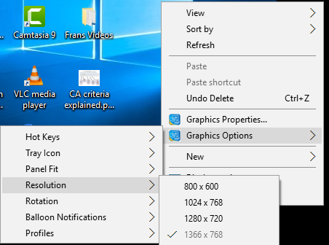

To set/change the screen resolution of a 24 Inch or bigger monitor on Windows XP / -NT or latest release:

1. Right-click anywhere on your Windows Desktop
2. Choose Properties (bottom of pop-up menu)
3. Click Settings Tab (last tab page)
4. Click and drag the bar at Screen Resolution to 1920 x 1080 Pixels
5. Click the OK button

**MODULE**

**2**

# Log in page

To access Integrator you need the use of Internet Explorer and Java 1.8 version 152 and higher (32 bit). Using your browser, use the URL relevant to your institution or link from the institutions’ local Intranet. You will be prompted for your user name and password. Username and passwords are set up in User Access Definitions {USERS-5} and maintained by the institution. A user can have multiple logins with the same user ID. It is dependent on institution rules and policies.

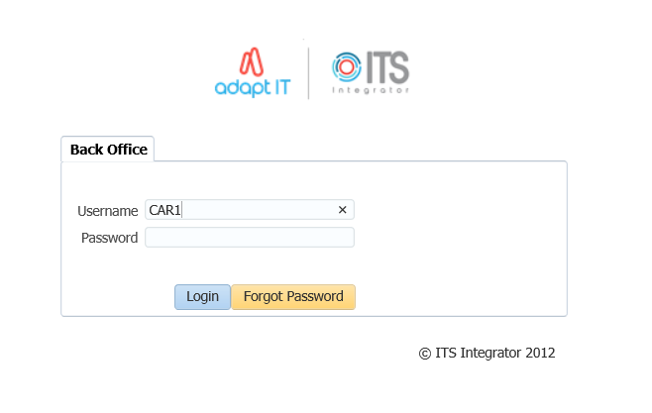

Once the login page has populated; enter your username and password. Select the ‘’login’’ button to gain access into the system.

After logging in, the Integrator Entry Screen will display.

**Forgot Password**

If you are having difficulty logging in to Back office or you forgot your password, you can reset your password.



1. Enter your Username
2. Click on the “Forgot Password” button

To be able to reset ITS/OID password, the users email address must be set up on {PBOP-14}/ {GOPS-3} and Primary Indicator for the email must be set to “Y”. If security questions are not set up on {USERS-17}, the user will get login control message to set up password questions and Answers.

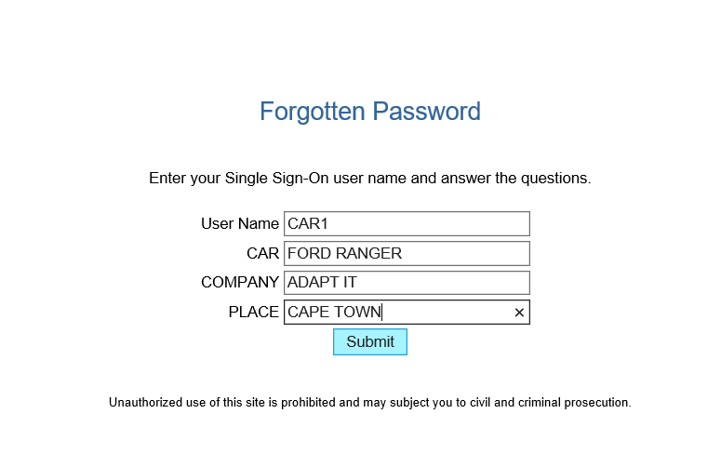

1. Answer the questions as set on {USERS-17}
2. click on “Submit button”

The notification pop up message to be illustrated

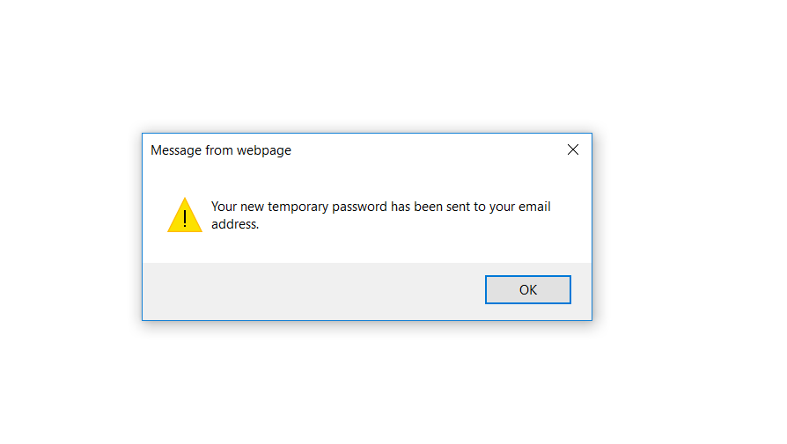

Logging in to ITS Integrator again with the given password on the email

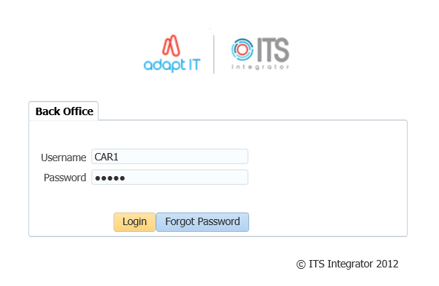

On the main page after logging onto integrator, on the More Tab, the Forgot Password Q and A can be found here and this will direct the user to {USERS-17}

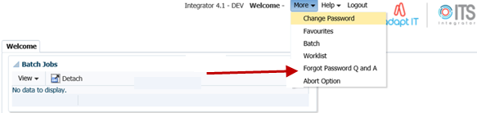

**MODULE**

**3**

# Integrator Entry Screen

## Landing page

After logging into the Integrator Back Office System the Integrator Entry Screen will display:



The Integrator Entry Screen is the gateway to the full ITS Integrator Back Office System as is made up of 4 sections: *Header, Main Menu Bar, Work Area, Welcome* and *Footer*.

| **Display** | **Where on Screen** | **Detail** |
| --- | --- | --- |
| **Header** | Top | This area contains the following:   * The Institution's Logo. This must be saved in the web/images directory as InsImg.jpg with dimensions of 125x56 * The user who logged in * "Home - Back Office" button which returns the user to the Integrator Entry Screen * "Logout" button which logs the user out of Integrator * "More" button which gives the user access to the following:   + Change Password   + Favourites   + Batch   + Worklist   + Abort * "Help" button which gives the user access to the following:   + Manuals - Gives the user access to the online Integrator help manuals   + Contacts - This will contain information for the person/department at the institution that is responsible for the Integrator system |
| **Main Menu Bar** | Left Side | The Main Menu Bar consists of two parts:   * Favourites - Will list all of the menus that the user has selected as favourites * Menu - Will allow the user to use the menu tree to get to the required menu. |
| **Welcome** | Middle & Right side | This part contains a search field that allow the user to search for the relevant menu that they require. The user can either search using the menu code and/or option, or for the name of the option |
| **Footer** | Bottom | This area contains the following links:   * Adapt IT Group. All Rights Reserved - Will redirect the user to an Adapt IT page * About Us -  The Institution can link this to their  home page * Terms of Use - The Institution can link their terms of use * Disclaimer - The Institution can link their disclaimer |

**Search:**

The searching of a menu/option now works differently to the forms based version of Integrator. The system will return all menus/options that contain the search criteria.

## Navigation to a menu option

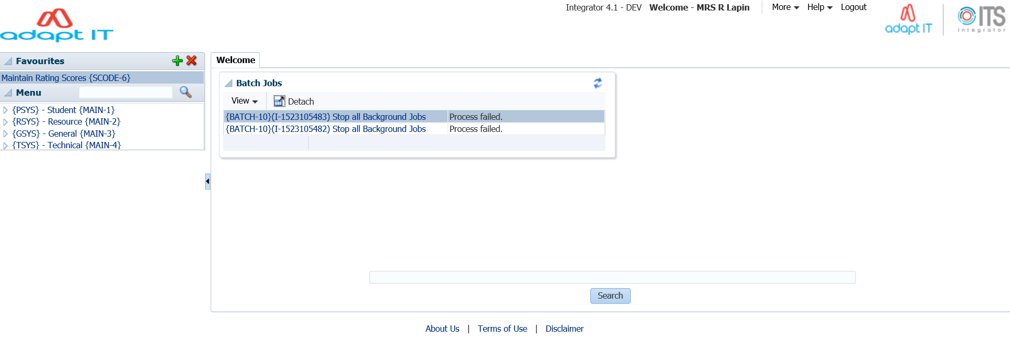

ITS Integrator 4.1 has two ways in which one can navigate to the menu options. The first can be seen on the main menu bar (left hand side) and the ‘’welcome’’ panel box.

Once the menu option has been inserted and the ‘’magnifying glass’’ selected; the menu search panel box will return all menus/options that contain the search criteria.

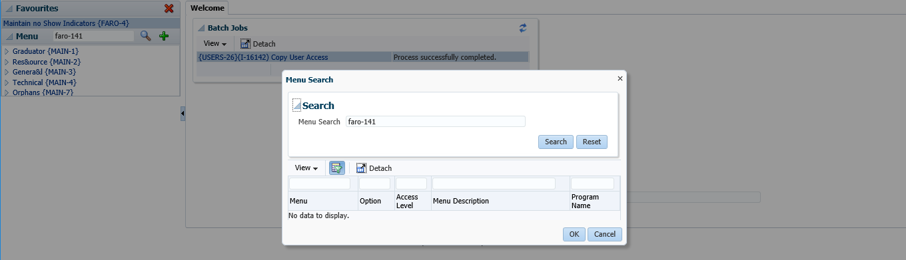

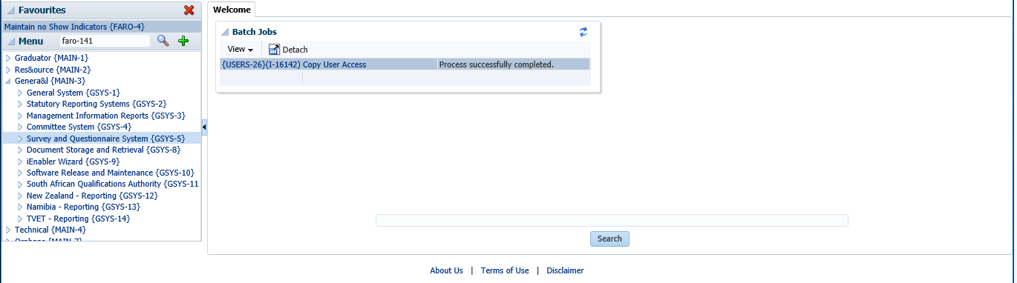

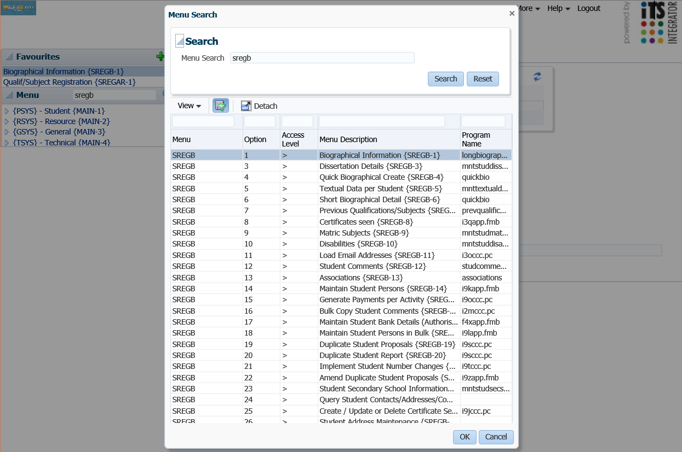

Alternatively, one can also use the tree search functionality to find the menu option desired



## Adding Favourites

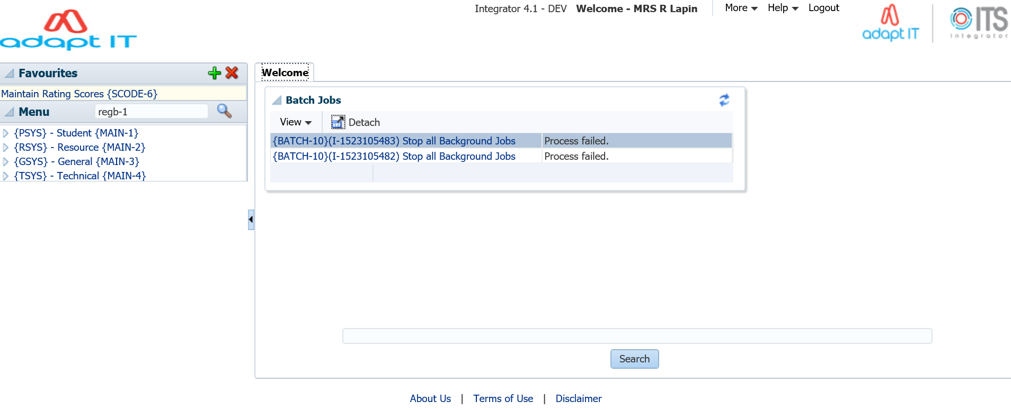

**2**

**3**

**1**

1. Open the desired menu
2. Click on the plus (+) button
3. Once this complete, the menu option will be added under the ‘’favourites’’ panel box

**MODULE**

**4**

# Accessing online help

On the Header; click on ‘’Help’’ and a dropdown with the options ‘’Manuals or About’’ will populate.

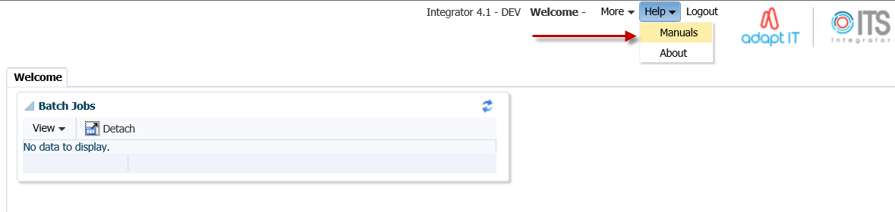

Select the Manuals option and the online help manual will display.

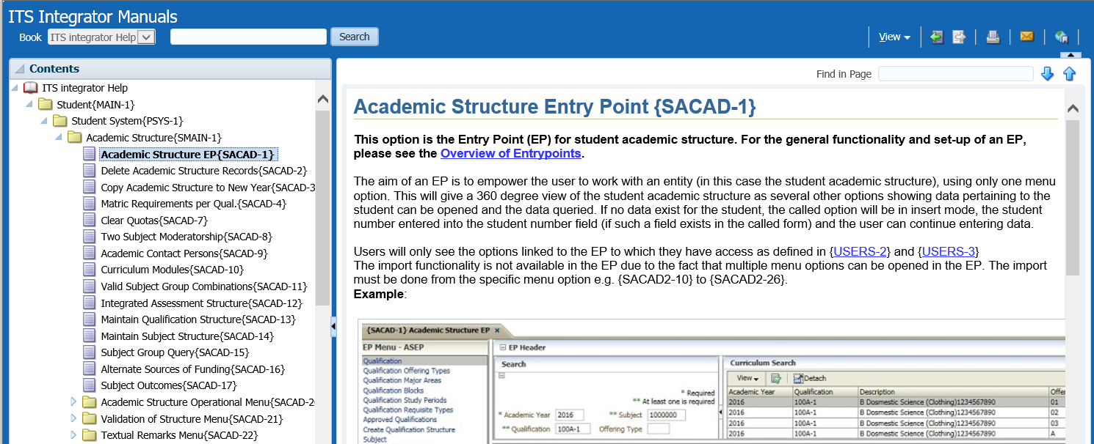

**MODULE**

**5**

# Accessing the Work list and Batch process

## Introduction

On the Header; the ‘’More’’ tab can be selected. Once selected a dropdown with the options ‘’change password, favourites, batch, work list and abort option’’ will populate. Select the batch or work list option.

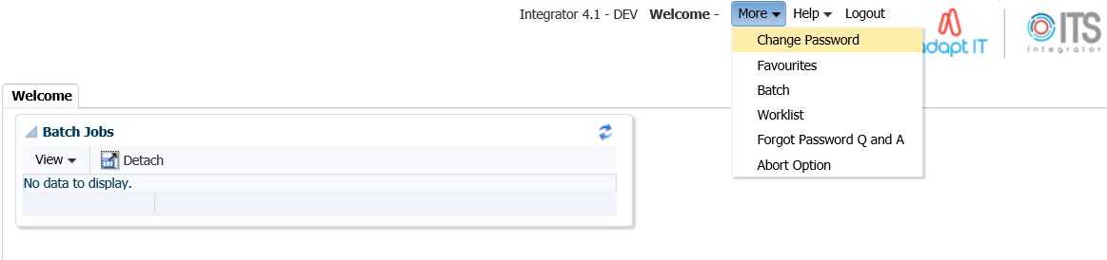

## Running a batch program

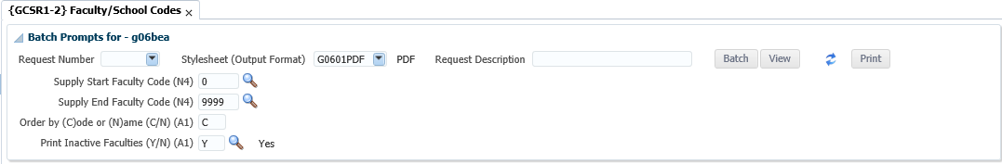

**3**

**2**

**1**

These are steps to follow when running a batch program report:

1. Select the output format
2. Press Tab to see more parameters and activate the batch butoon
3. Click on Batch

This is what the screen looks like once the report has run

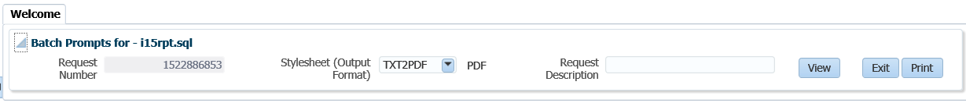

**1**

2\2

These are the steps to follow when running a batch program report:

1. Click on View to view the output in a browser tab
2. Click on Print to print through the system (unix)

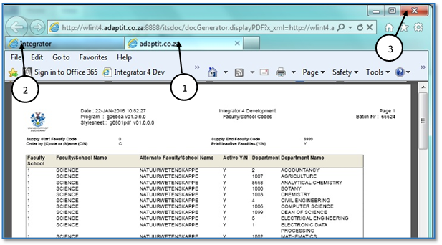

1. The output opens in a separate browser tab
2. Choose the original tab to navigate back to the system
3. Note: Do not close the Browser Window as it will close the whole session

**MODULE**

**6**

# Reports

## Introduction

The ITS Integrator 4.1 have been converted to Jasper which is a reporting and Business Intelligence tool.

## Jasper Reports

The infrastructure for the integration of Jasper reports is now in place on the Integrator 4.1 backoffice application.

* The first set of reports to be converted is based on the use of .RDF Technology
* Soft Transition
* Internal/External reports
  + Parameter display
  + Headings
* Report Formats

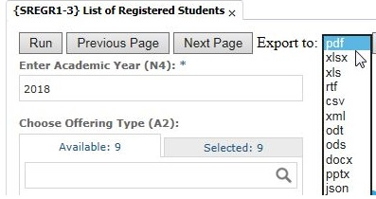

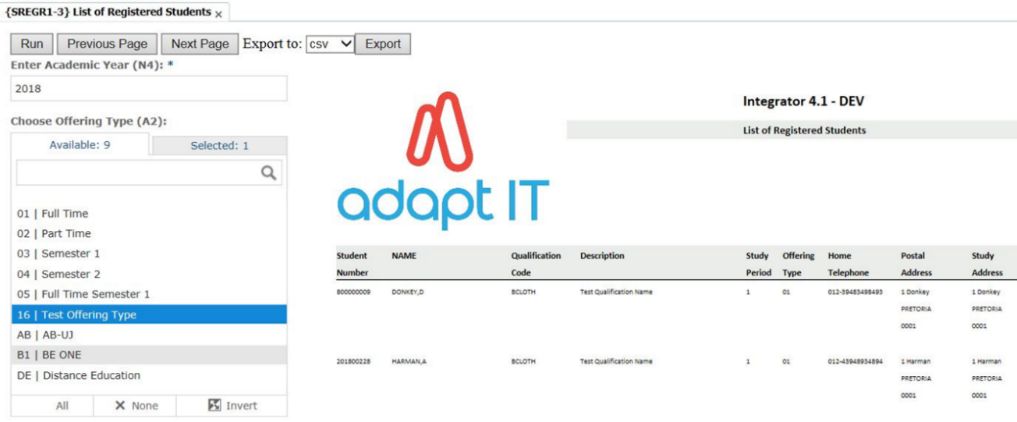

**MODULE**

**7**

# Forms

## Introduction

Some options still open Forms Programs and will be converted to the new ADF technology in the near future.

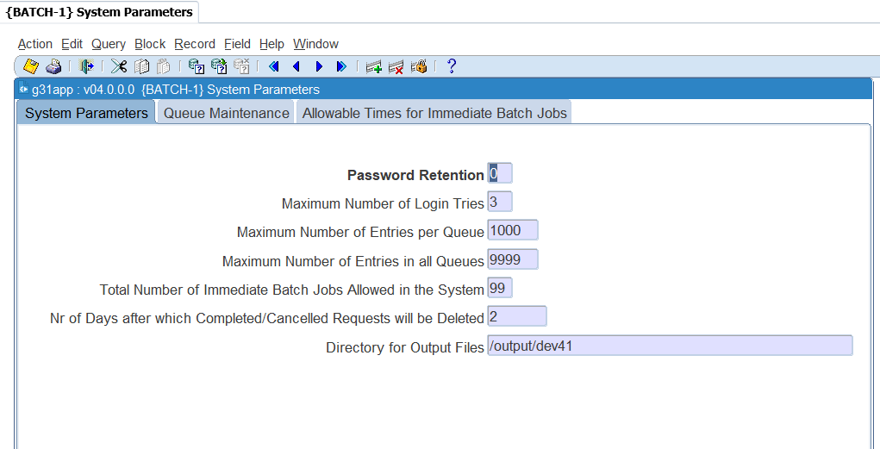

## Specific Rules Related to Forms Programs

1. Add the URL to run in Compatibility View

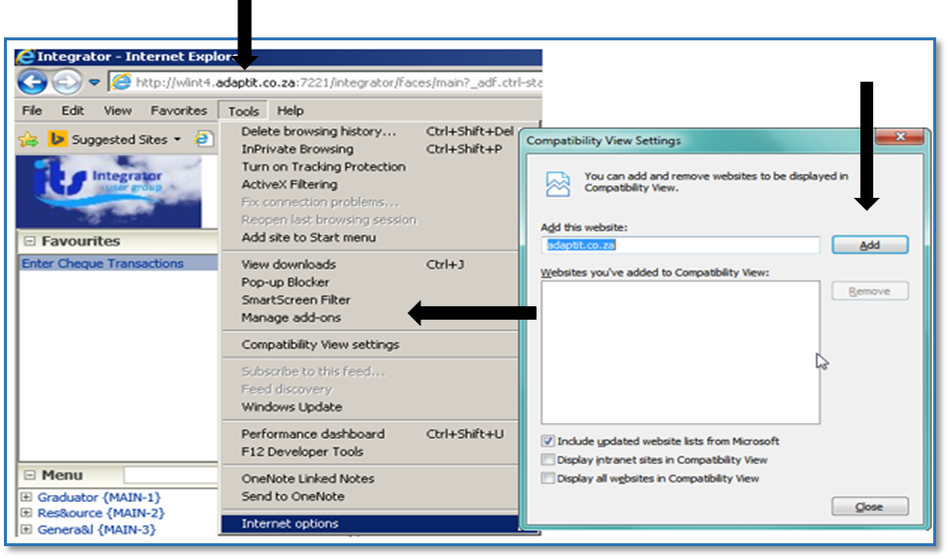

1. Add the Server to the Trusted Sites

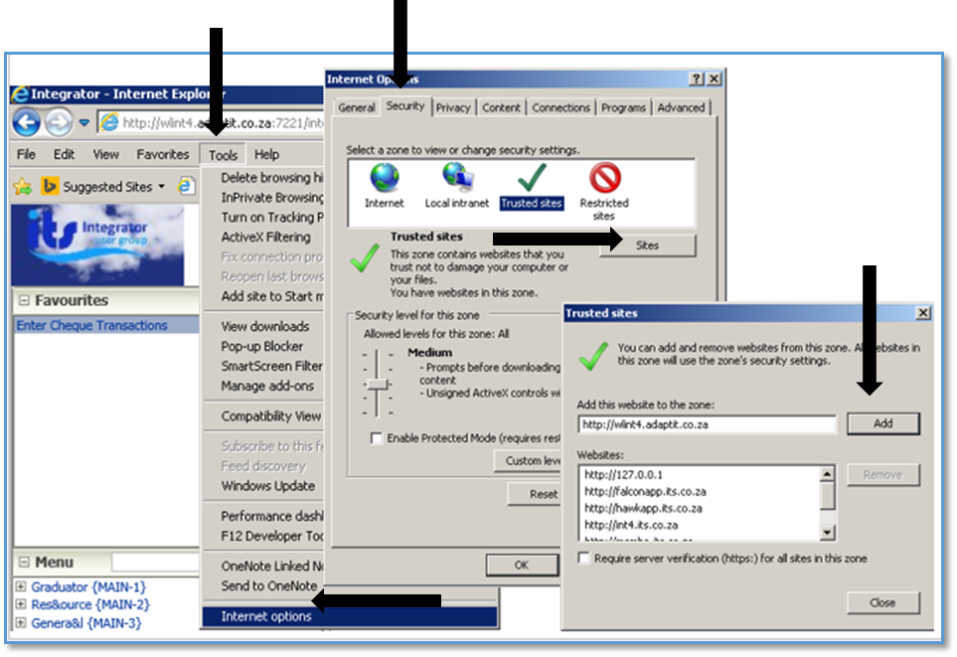

1. Select the Tools options 🡪 Internet Options 🡪Security 🡪 Trusted Sites 🡪 Sites 🡪 Entre URL 🡪 Add

## Specific Rules Related to Forms Programs



**2**

**1**

1. Always Exit using the “Exit” icon (Green Door iCon).

*Refrain from using the “Home – Back-Office” link in the header, unless the forms program does not open or is stuck due to Java 1.8 not being set-up correctly on the user’s PC or laptop.*

1. Always use the “Enter Query” icon.

**Please note:** The use of the F11 – key for “Enter Query” and other keystrokes is discouraged because browsers have their own ways of handling keys.

**MODULE**

**8**

# Screen Patterns

## Introduction

Different screen patterns are identified. The screen types used are based on the type of interaction and the number of records accessed.

## Entry Point (EP)

The aim of an EP is to empower the user to work with the Academic structure using only one menu option. This is described using the Academic Structure Entry point {SACAD-1} as an example. Users will only see the menu options linked to the EP to which they have access.

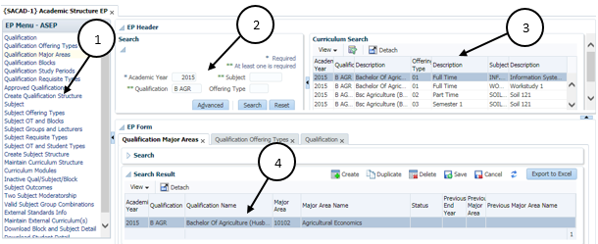

* 1. The EP Menu controls access to the individual options
  2. Search Panel for entry of Search criteria
  3. Search Results presented in table format
* The user should click on the “Detach” icon to see the complete information in table format without scrolling up and down as shown below
* Click on the “Detach” button to return back to previous Form.
  1. EP Form displays Qualification/Subject with focus as per selected EP control

## Simple Codes Table (TCS)

Simple codes table without a Search Panel, E.g. Work/Shift Patterns {COOPC-27}.

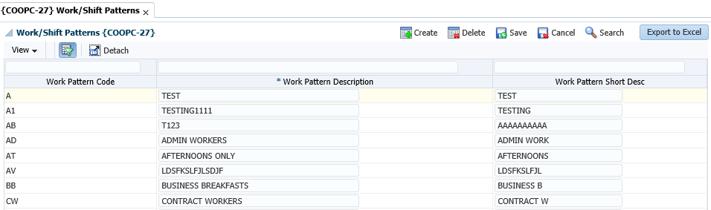

1. Create button can be used to create a new record and the empty row will display.
2. Data is presented in an updatable table format.
3. The User can click on the “Detach” icon for better view of data
4. Export to Excel button

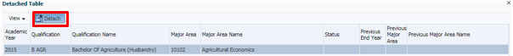

* Always allows Read (Query) and at least one of Create, Update or Delete operation
* Information is queried automatically
* Record level validations only, or, simple field level validations
* No cross-field dependencies
* Low volume of records and < 10 fields

## Table with Search Panel (TCM)

Simple table with a Search Panel, for small to medium size CRUD, e.g. Certificates Seen {SREGB-8}

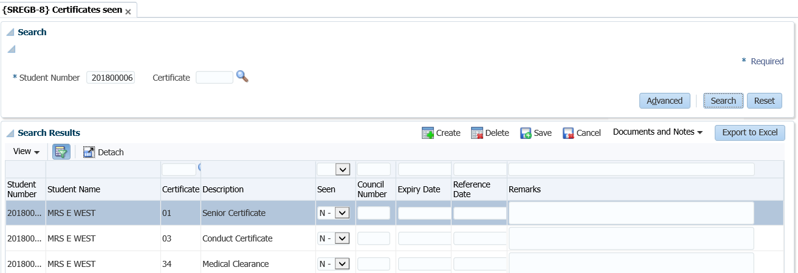

* Always allows Read (Query) and at least one of Create, Update or Delete operation
* No automatic querying
* Possible cross-field dependencies and complex validations
* Less than 30 fields

## Multiple tables/Columns with Search Panel (TCL)

CRUD Table (one or more) with collapsible column groups or column hiding and Search Panel for Large size CRUD e.g. Curriculum {SACADO-17}

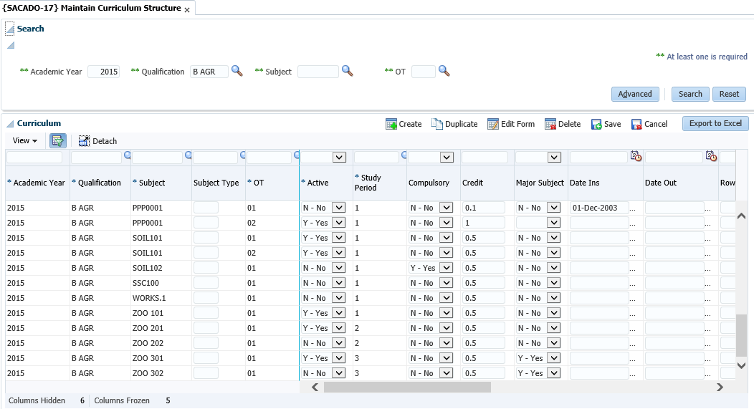

1. Search Panel where the user can type in the query criteria
2. Search Results is displayed in the table format
3. Export to Excel button
4. The information on the table can be detached for better viewing of the information presented in the table format
5. Duplicate existing record.

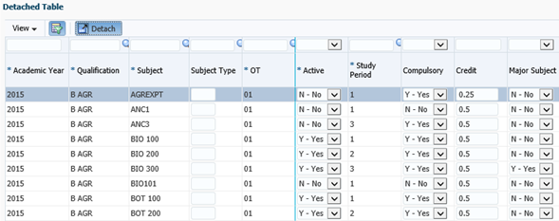

* Always allows Read (Query) and at least one of Create, Update or Delete operation
* No automatic querying
* Possible cross-field dependencies and complex validations
* More than 30 columns.

## Search panel with results in query-only table (TQ)

Query-only e.g. Query Student Account {FSAO-7}

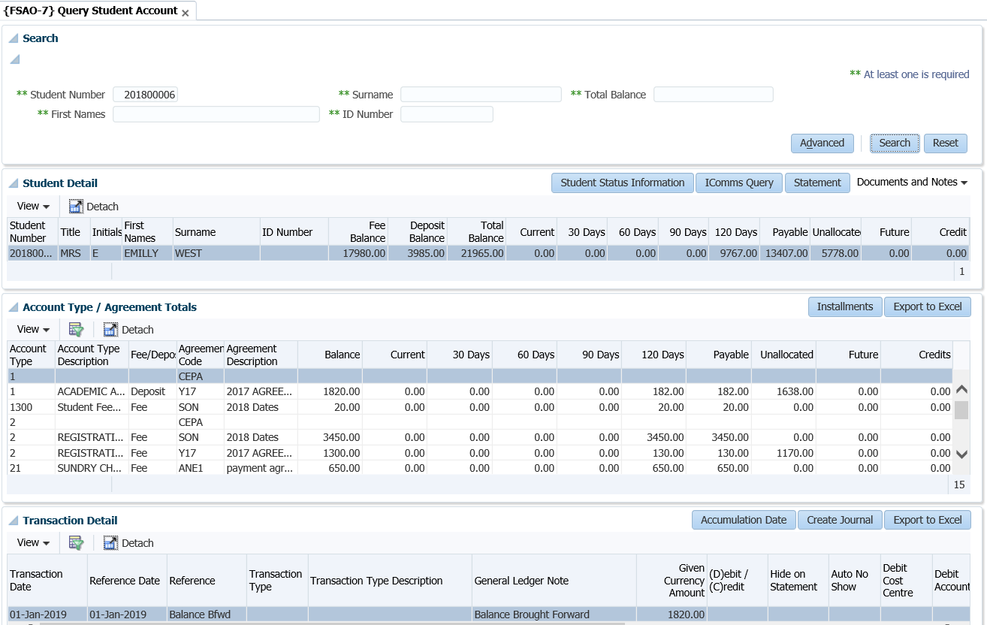

* Always allows Read (Query) and at least one of Create, Update or Delete operation
* No automatic querying
* Possible cross-field dependencies and complex validations
* Less than 30 Columns in table

## Search panel with results in query-only tree table (TT)

Query-only e.g. Revenue Expense Query {FGLO-10}

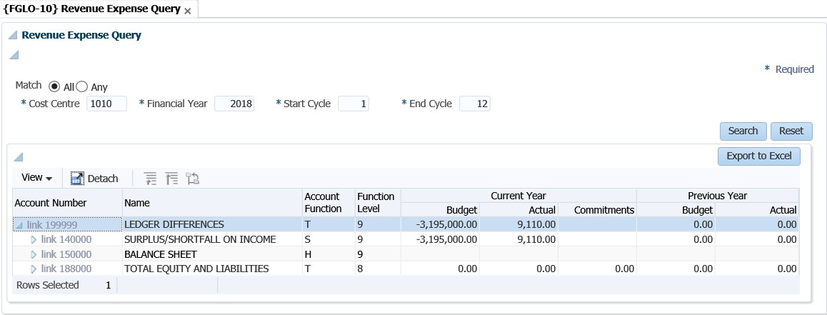

## Search Panel, Search Results Table with CRUD Form at the bottom(FCM)

Small to medium size CRUD e.g. Curriculum {PBOP-8}

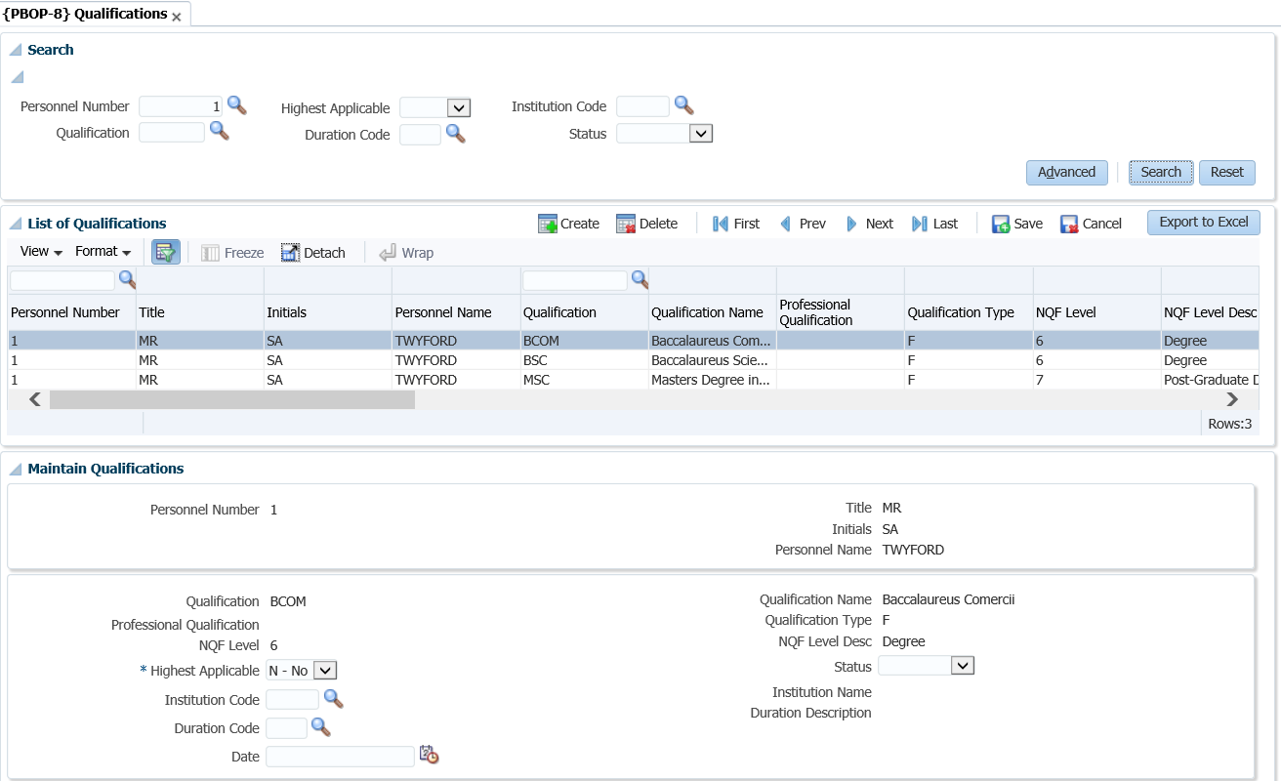

* Always allows Read (Query) and at least one of Create, Update or Delete operation
* No automatic querying
* Possible cross-field dependencies and complex validations
* Less than 30 Columns in table

## Search Panel, Search Results Table (one or more) with pop-up CRUD Form (FCM-PC)

Small to medium size CRUD e.g. Query Student Account {FSAO-7}.

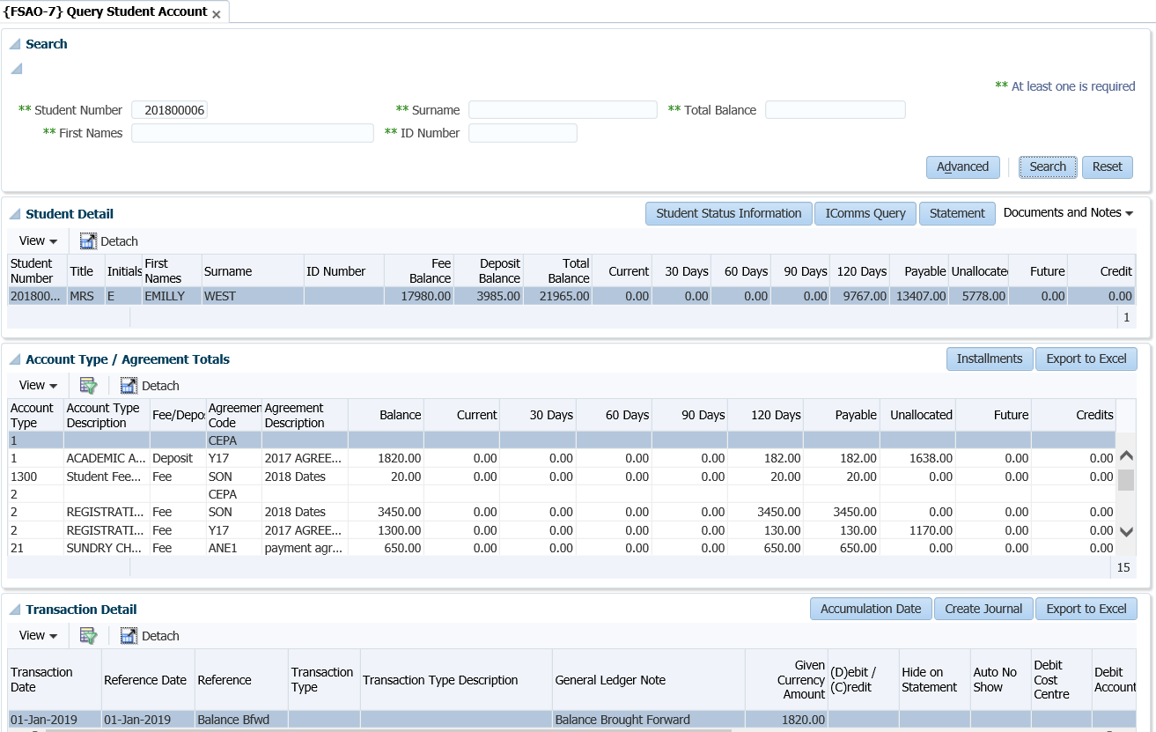

* Always allows Read (Query) and at least one of Create, Update or Delete operation
* No automatic querying
* Possible cross-field dependencies and complex validations
* Less than 30 Columns in table

## CRUD Form with Search pop-up or Search Panel (FCL)

Large size CRUD e.g. Query Student Account {FSAO-1} or Define and Maintain Subject {SACADO-10}.

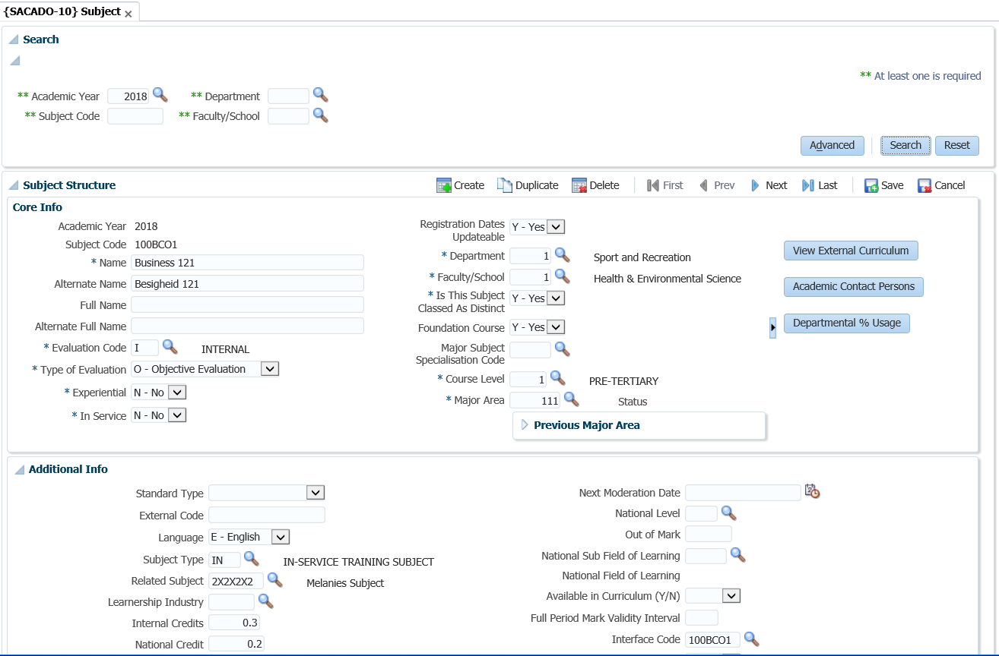

* Always allows Read (Query) and at least one of Create, Update or Delete operation
* No automatic querying
* Possible cross-field dependencies and complex validations
* More than 30 Columns in table

## Search Panel with Search Result Table and CRUD Form on different page (FCL-TSL)

Large size CRUD e.g. Post Establishment {PPEO-1}.

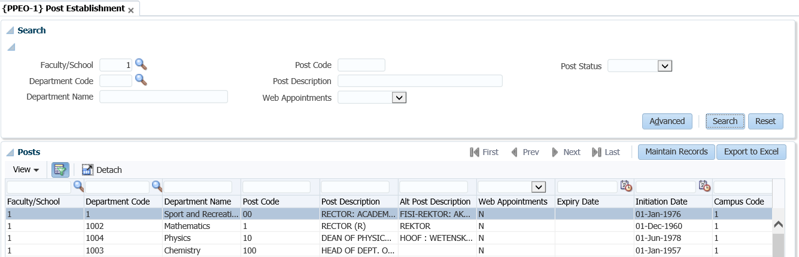

* Always allows Read (Query) and at least one of Create, Update or Delete operation
* No automatic querying
* Possible cross-field dependencies and complex validations
* More than 30 Columns in table

## Create only Form (FCO)

Create-Only e.g. Bank Statement Reconciliation {FCBO-4}

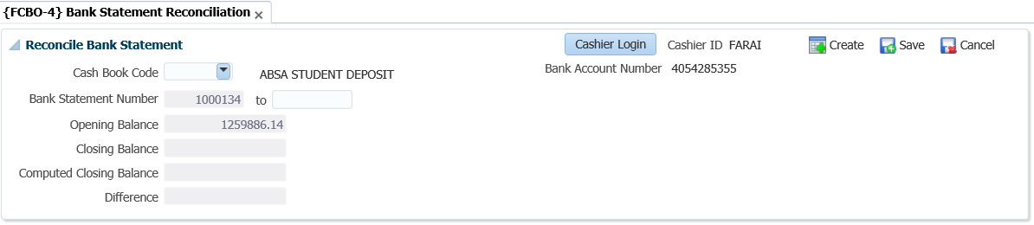

**MODULE**

**9**

# The Search Dialogue

To search; select the ‘search’ option on the right hand side of the screen. Once selected, the ‘Search dialog’ box will populate. Various search criteria’s can be supplied to access the data desired.

An advanced search option is also available.

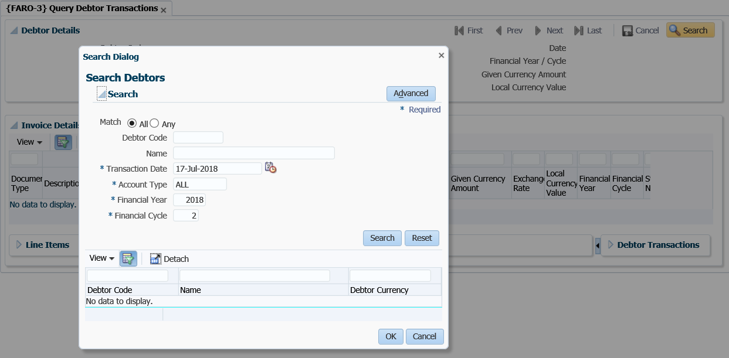

Once the advance search option has been selected; a number of search fields will populate. On the list of fields available, you can choose the field applicable to your Institute or department filter, for future searches.

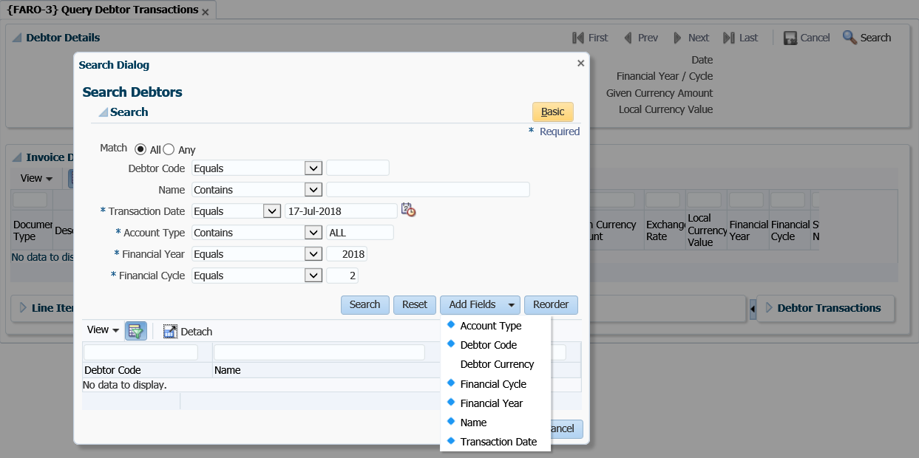

## Search Panel, Search Results Table with Form at the bottom

Each menu has got different panel boxes available on one page. Most Panel boxes comprise of the Search panel, the Search results panel and the forms at the bottom of the page.

Qualifications {PBOP-8}

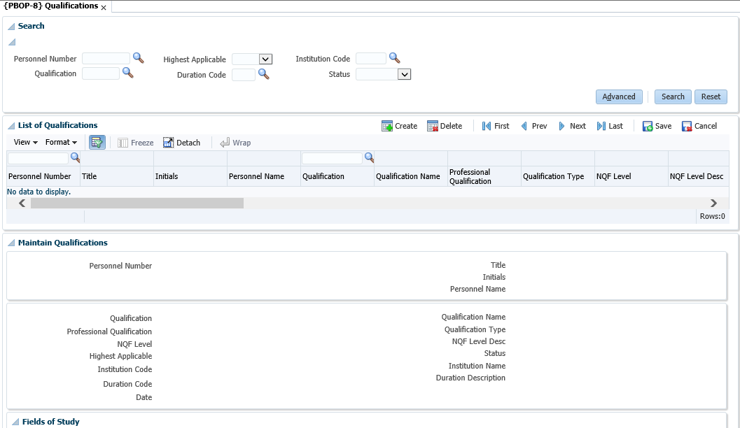



Maintenance Form

Results Table

Search Panel

### Search Panel

Fields that appear here are only used to “Search”, in other words, they are “Query Criteria”.

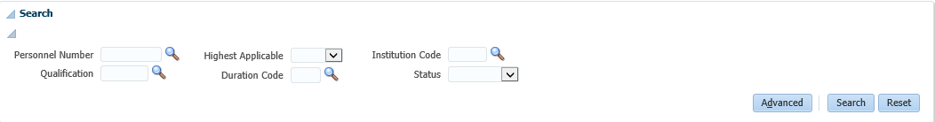

**Search** will search the database for records that match the “Search – Criteria” and display them in the Results Table. Clicking Search when all the fields in the Search Panel is blank (or null), will return all records, otherwise only those that match the fields in the Search Panel. It can be closed by clicking on the Disclose / Close icon

**Advanced** allows the user to “Search” in an advanced way and/or to add fields to the Search Panel

**Reset** will only make the value fields in the Search Panel blank (or empty or null), it will not clear the Results Table or the Form at the bottom.

### Results Table

In this User Interface Pattern, data in the Results Table cannot be updated. The record selected here will be available in the Form for update purposes

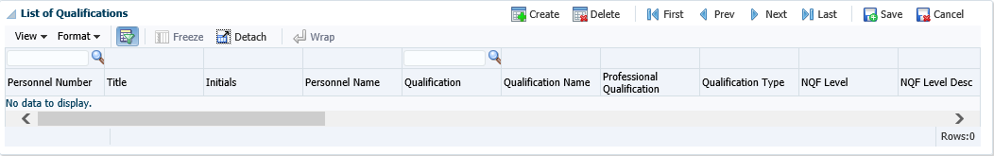

**Delete** will delete the selected record (It only becomes effective in the database after clicking Save)

**Create** will create a new record with blank fields. (It will be available in the Form to complete and it only created in the database after clicking Save)

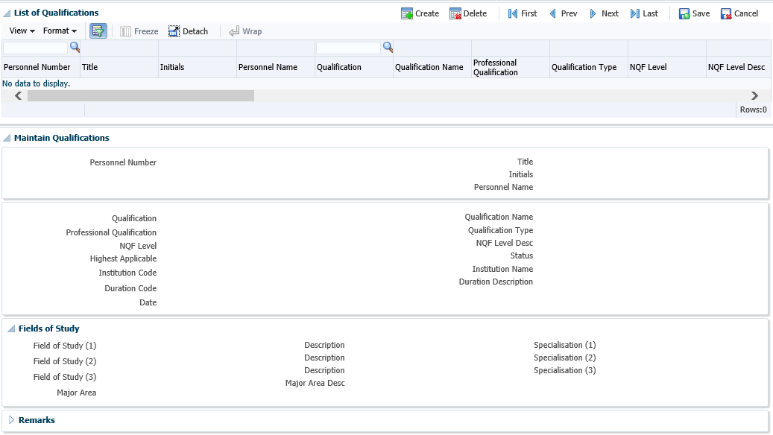

**3**

**2**

1

1. Menu Bar above the Results Table
2. Close / Disclose icon to hide or open Panel Box
3. Combo Box List

## Search Panel, Search Results Table, Form on different page

Post Establishment {PPEO-1}

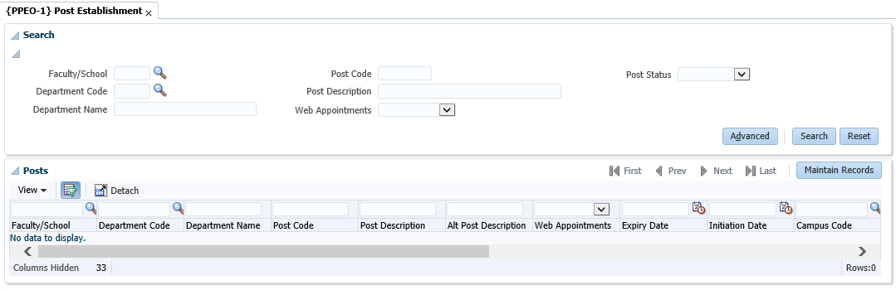

**1**

1. The same as the previous pattern, but use Toolbar Buttons to navigate between the Search Panel / Search Results and the Maintenance Form

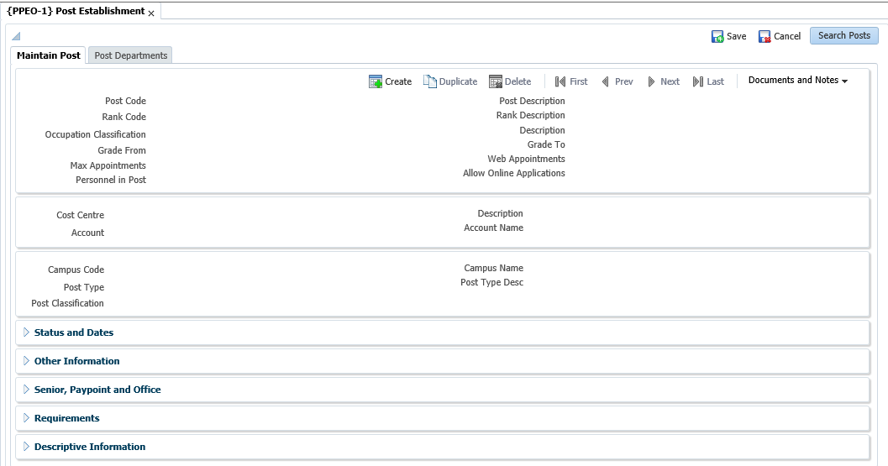

**2**

**1**

1. Navigation back to Search Panel and Results Table
2. These Panel Boxes are closed by default and can be disclosed using the Close / Disclose Buttons

**Acronyms, Glossary & Terminology**

**Acronyms**

|  |  |
| --- | --- |
| **Acronym** | **Definition** |
| **DSL** | Data Sheet Layout (spreadsheet format of selected applications) |
| **DSR** | Document Storage and Retrieval |
| **EP** | Entry Point |
| **ES** | Entry Screen (menu/front end) |
| **iComms** | I-Communications - New Implementation of Selected Letters, Lists and Labels via Desktop Integration. I.e. Creating Letters with a Word Processing Application outside the ITS Back -Office System. |
| **iGrams** | A Visual Representation of Complex Data for Simplification. |
| **LOV** | List of Values |
| **OID** | Oracle Internet Directory |
| **PCL** | Printer Controlled Language |
| **PoE** | Portfolio of Evidence |
| **SMS** | Student Management System |
| **SSO** | Single Sign On |
| **URL** | Uniform Resource Locator. Usually pronounced by sounding out each letter but, in some quarters, pronounced "Earl" - is the unique address for a file that is accessible on the Internet. |
| **XML** | Extensible Mark-up Language. A mark-up language like HTML, used in reporting and iComms |
| **XSL** | Extensible Style sheet Language. A style sheet defining the output format of XML |

**Glossary**

|  |  |
| --- | --- |
| **Term** | **Definition** |
| **Block** | A section of screen that displays related information associated with a record. |
| **Canvas** | Any ‘white space’ on a screen. Right-clicking on the canvas usually offers additional options. |
| **Database** | An electronic system of storing and retrieving information so that it can be displayed according to a number of predetermined formats. |
| **Execute query** | The act of conveying search criteria to retrieve and display selected data. |
| **Field** | A box on the screen that displays numeric or alphanumeric information, or permits numeric or alphanumeric information to be entered. |
| **List of Values** | A list of codes (numeric or alphanumeric) accessible through menus in certain fields.  **Note:** Is represented by an ellipsis or  at the end of the field. |
| **Output** | The displayed or printed result by which information is requested from the database through a query or entered search criteria. |
| **Query** | A database term for a search carried on one or more fields on a screen. |
| **Query criteria** | Search criteria used in a query. |
| **Record** | A data structure composed of one or more fields. |
| **Report** | The displayed or printed output resulting from report criteria used to generate a report. |
| **Report query** | Criteria used to search the database so that a report is generated. |
| **CRUD** | Create/Read/Update/Delete operations. |
| **MPM** | Multi-Processing Module |
| **Panel Boxes** | A Panel Box is used to place ancillary information on a page, offset by a certain colour / border. |
| **UI** | User Interface |

**Terminology**

|  |  |
| --- | --- |
| **Term** | **Definition** |
| **Academic structure** | This is the structure of all academic qualifications / study programs offered by a university, linked to a faculty, then to an academic department, and then linking all the subjects / courses / modules that form part of the curriculum to the qualification / program. It includes all pre- and co-requisites per subject / course, credits per subject / course / module, formats of offering and all relevant information related to the completion of a particular qualification, i.e. degree, diploma, etc. This structure is maintained on the university’s student information system. |
| **Analyze** | Interpretation  Apply of processes  Examine, Investigate, Consider, Evaluate or Scrutinizes |
| **Block** | A section of screen that displays related information associated with a record. |
| **Calculate** | Compute |
| **Canvas** | Any ‘white space’ on a screen. Right-clicking on the canvas usually offers additional options. |
| **Compile** | Collect, Assemble, Accumulate or Gather |
| **Copy** | Duplicate |
| **Database** | An electronic system of storing and retrieving information so that it can be displayed according to a number of predetermined formats. |
| **Dean** | The person who has been appointed by the university as the academic head of a faculty. |
| **Department** | A sub-section of a faculty’s organizational structure, based on an academic field and / or main subject, whereas the particular department is responsible for the qualifications or study programs that are linked to the field or main subject. An academic department is headed up by a Head of Department (HOD). |
| **Execute query** | The act of conveying search criteria to retrieve and display selected data. |
| **Faculty** | A sub-section of a university’s academic structure, based on a collective but related number of study fields or subjects, e.g. Faculty of Medicine. A faculty is headed up by a Dean. |
| **Faculty Administrator** | The person who has been appointed to execute the administrative functions of a faculty that includes inter alia student administration, financial administration and committee administration. |
| **Faculty Manager** | The person who has been appointed to manage the overall administrative functions of a faculty, and who is a member of the faculty’s executive management team. |
| **Field** | A box on the screen that displays numeric or alphanumeric information, or permits numeric or alphanumeric information to be entered. |
| **Generate** | Create or Delete Data  Compute Results  Adjust Results  Print or Run a Report  Print or Run a List  Print or Run a Letter  Print or Run a Label  Print or Run a Log File |
| **HOD** | The person who is appointed as the head of an academic department. |
| **List of Values** | A list of codes (numeric or alphanumeric) accessible through menus in certain fields.  **Note:** Is represented by an ellipsis or  at the end of the field. |
| **Maintain** | Create, Capture, Insert or Enter Records  Delete, Purge Records  Update, Change or Rectify Records |
| **Output** | The displayed or printed result by which information is requested from the database through a query or entered search criteria. |
| **Query** | A database term for a search carried on one or more fields on a screen. |
| **Query criteria** | Search criteria used in a query. |
| **Record** | A data structure composed of one or more fields. |
| **Report** | The displayed or printed output resulting from report criteria used to generate a report. |
| **Report query** | Criteria used to search the database so that a report is generated. |
| **Rollback** | Reversal |
| **Screen** | All that relates to data can be displayed or entered in fields in one or more blocks. |
| **Utilize** | Query, View, Understand or Use Information |
| **Verify** | Check, Control, Confirm or Validate Information |

# Need Help

You can refer to our online help manual available on the system or alternatively contact the Adapt IT – Consulting and Training team.

**Physical Address**

152 14th Rd

Noordwyk

Midrand, 1687

Johannesburg

South Africa

**Tel**: +27 (10) 494 0000

**Email**: [EDU.consulting@adaptit.co.za](mailto:EDU.consulting@adaptit.co.za)

**Website**: [www.adaptit.co.za](http://www.adaptit.co.za)